ML Lab Assignments

**Name:** Umang Patel

**Class:** TY CSE IS III **Roll No:** 2193271

**Enrolment No:** MITU19BTCS0202

**Assignment 1**

**Aim:** Installation and Configuration of machine learning environment with Anaconda on Ubuntu (Jupyter notebook)

**Objective:** To install anaconda and configure it with Python

## Theory:

**Installation Of Anaconda in Ubuntu:**

1. Visit the Anaconda downloads page
2. Select Linux
3. 3. Copy the bash (.sh file) installer link
4. Use wget to download the bash installer
5. Run the bash script to install Anaconda3
6. source the .bash-rc file to add Anaconda to your PATH

## NUMPY/SCIPY:-

* + NumPy is a Python library, which stands for ‘Numerical Python’.
  + It is the core library for scientific computing, which contains a powerful n-dimensional array object, provide tools for integrating C, C++ etc.
  + NumPy array can also be used as an efficient multi-dimensional container for generic data.
  + The ndarray (NumPy Array) is a multidimensional array used to store values of the same datatype. These arrays are indexed just like Sequences, starting with zero.
  + The ndarrays are better than regular arrays in terms of faster computation and ease of manipulation.
  + In different algorithms of Machine Learning like K-means Clustering, Random Forest etc. we have to store the values in an array. So, instead of using a regular array, ndarray helps us to manipulate and execute easily.

## Installation Of NumPy - pip3 install numpy , Import numpy as np

* + **Installation of Scipy-stack - pip3 install scipy-stack**

## SCIKIT:-

The functionality that scikit-learn provides include:

* + Regression, including Linear and Logistic Regression
  + Classification, including K-Nearest Neighbors
  + Clustering, including K-Means and K-Means++
  + Model selection
  + Preprocessing, including Min-Max Normalization.

## Installation of scikit pip3 install -u scikit-learn

**PANDAS:-**

With Python Pandas, it is easier to clean & wrangle with your Data. features of Pandas make it a great choice for Data Science and Analysis.

* + Merging and Joining Data Sets.
  + Reshaping & pivoting Data Sets.
  + Inserting & deleting columns in Data Structure.
  + Aligning data & dealing with missing data.
  + Iterating over a Data set.
  + Analyzing Time Series.
  + Filtering Data around a condition.
  + Arranging Data in an ascending & descending.
  + Reading from files with CSV, TXT, XLSX, and other formats.
  + Manipulating Data using integrated indexing for DataFrame objects.
  + Generating Data range, date shifting, lagging, converting frequency, and other other Time Series functionality.
  + Subsetting fancy indexing, & label based slicing Data Sets that are large in size.
  + Performing split apply combine on Data Sets using the group by engine.

## Installation of Pandas - pip3 install pandas

**MATPLOTLIB:-**

* Matplotlib is a visualization library in Python for 2D plots of arrays. It consists of several plots like line, bar, scatter, histogram etc.
* Matplotlib is a multi-platform data visualization library built on NumPy arrays and designed to work with the broader SciPy stack.It can also be
* used with graphics toolkits like PyQt and wxPython. One of the advantages of visualization is that it allows us visual access to huge amounts of data in easily digestible visuals.

## Installation of Matplotlib - pip3 install matplotlib

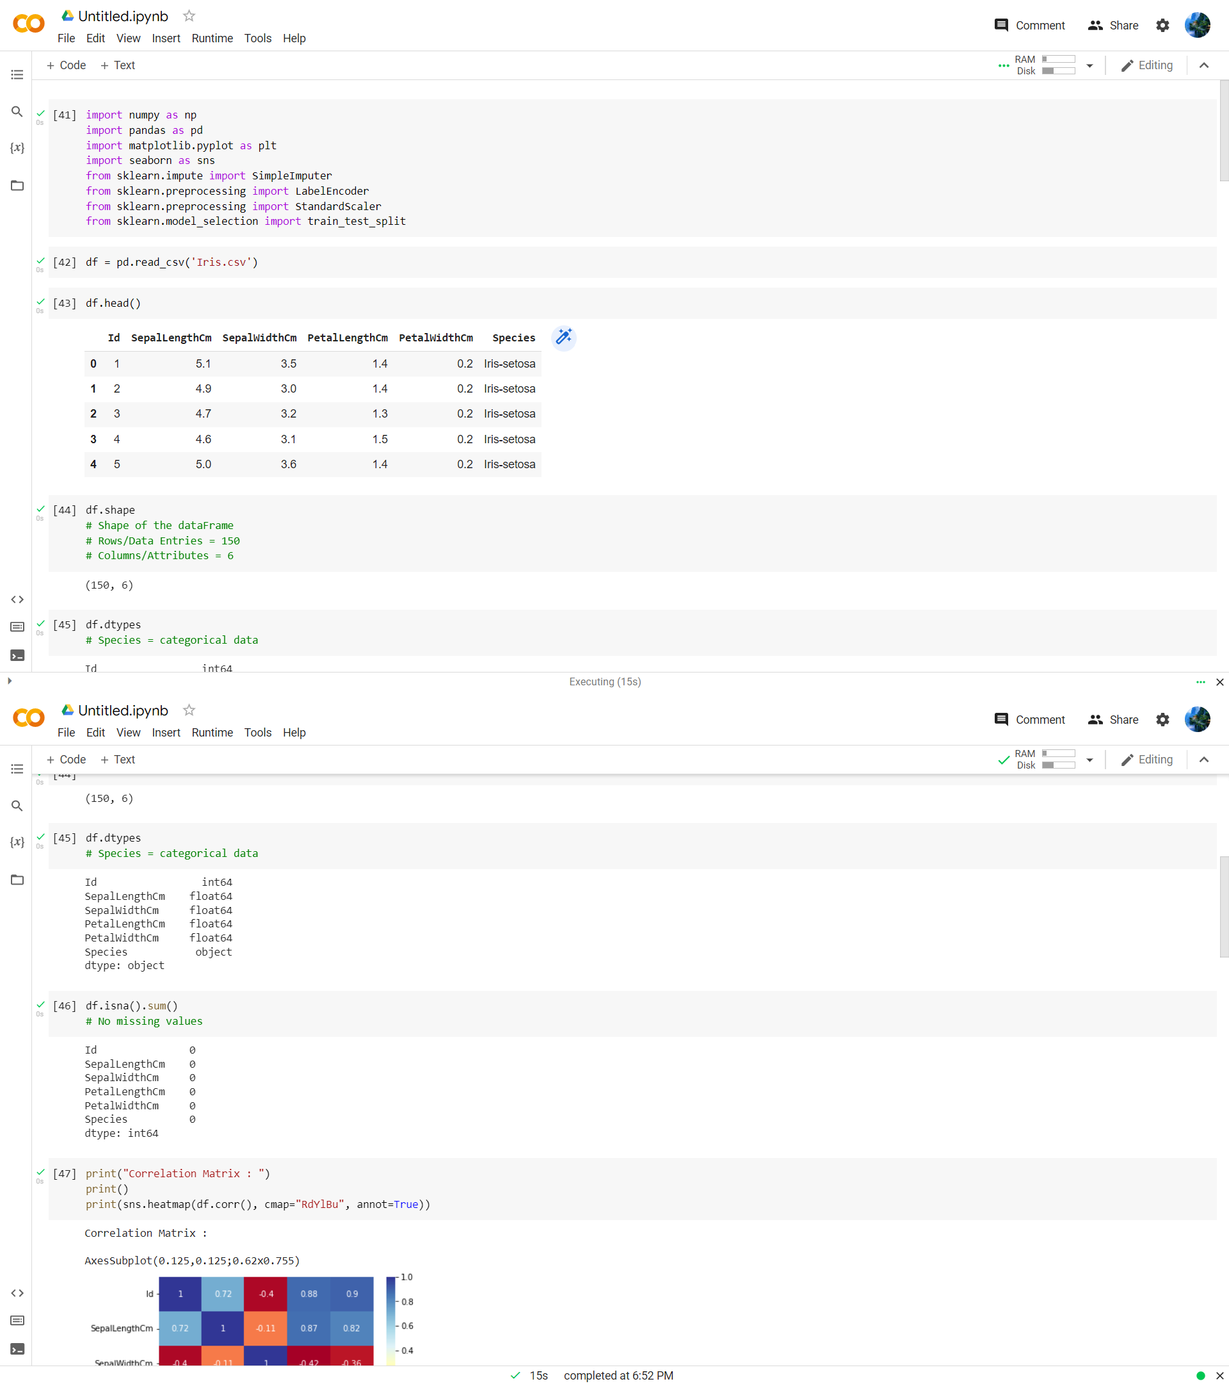

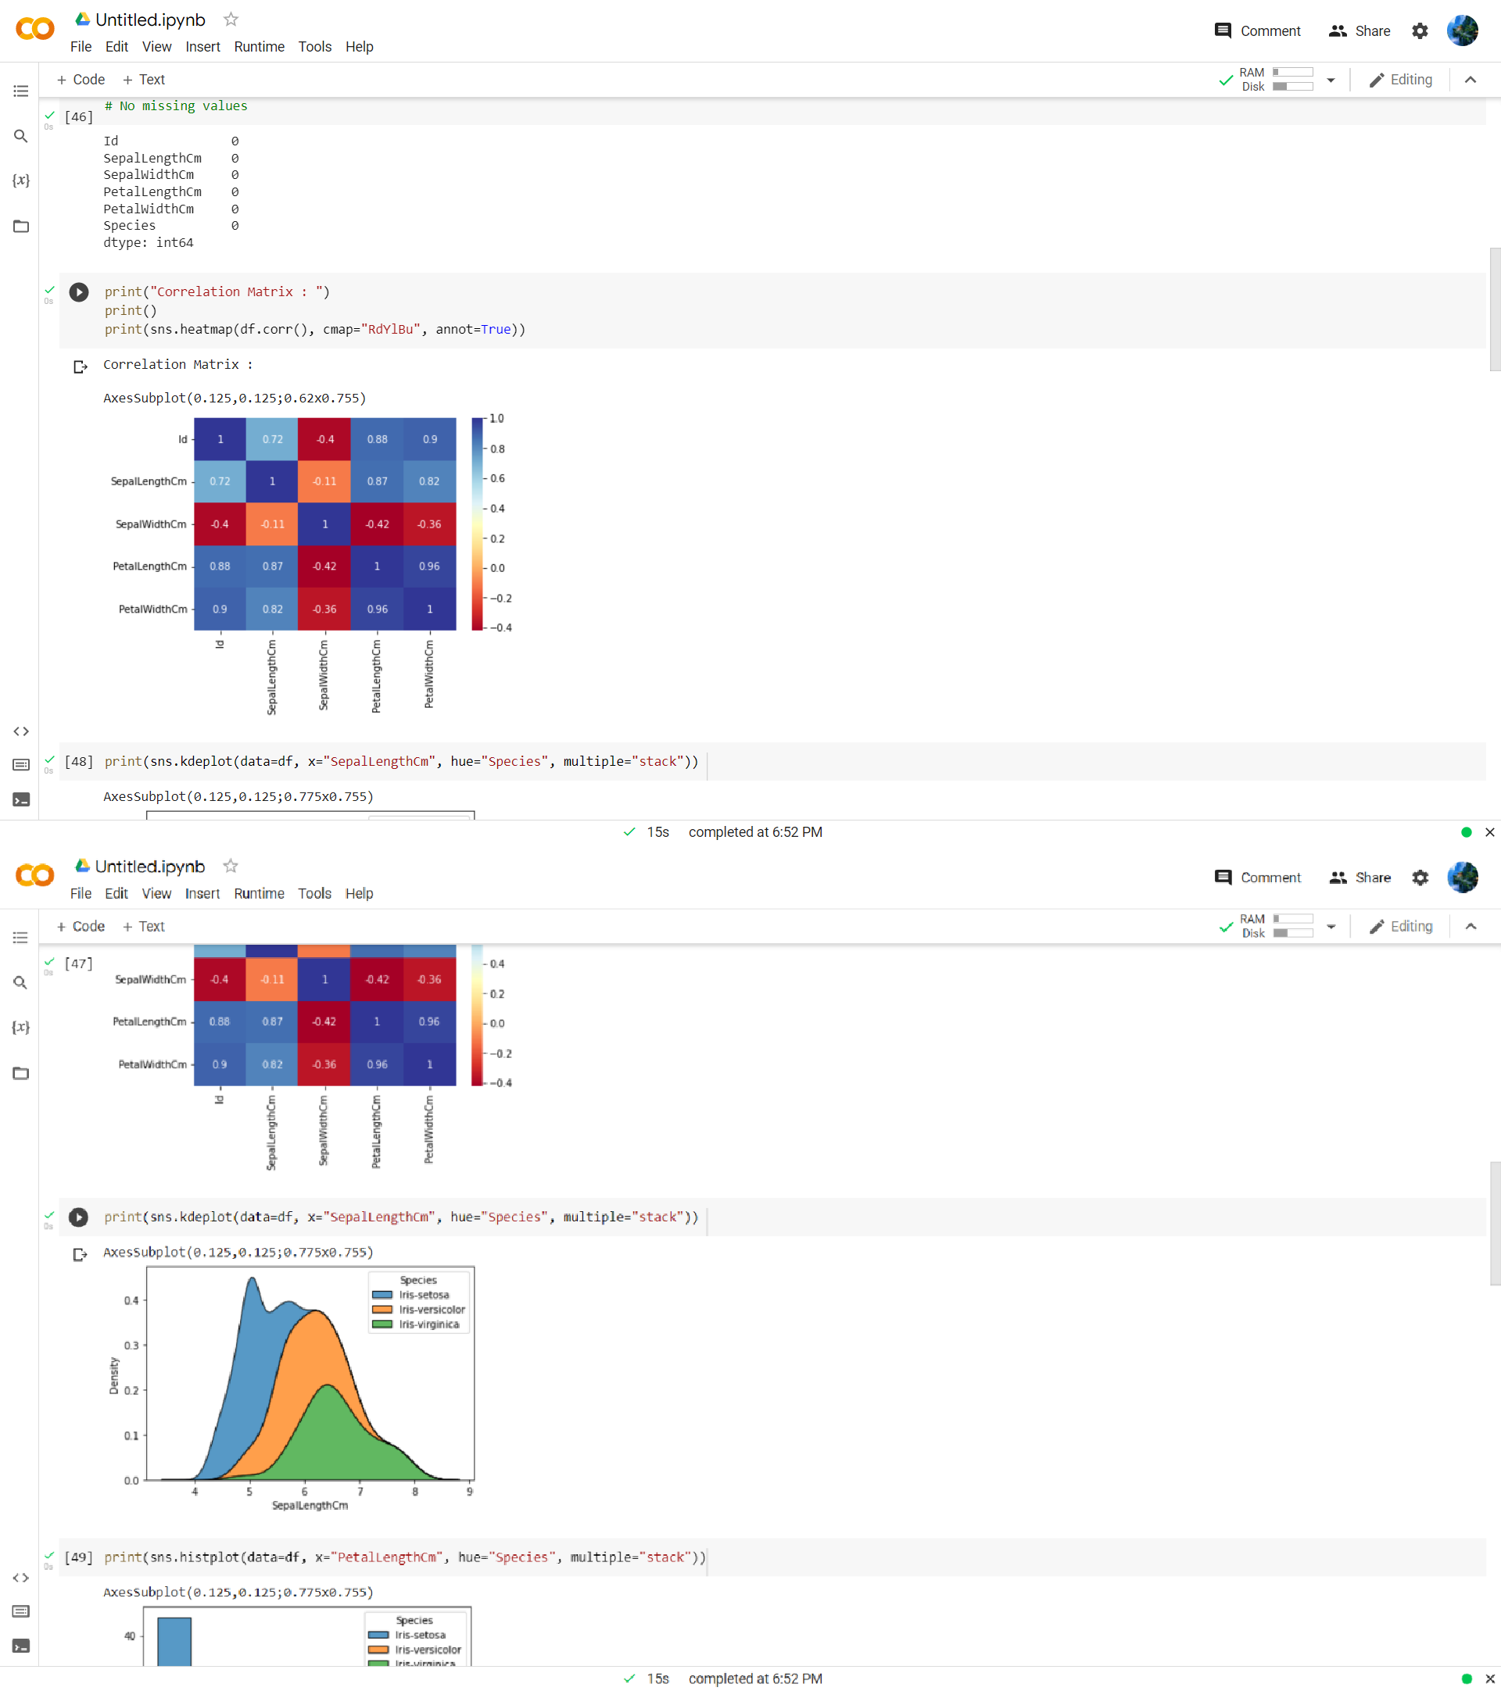

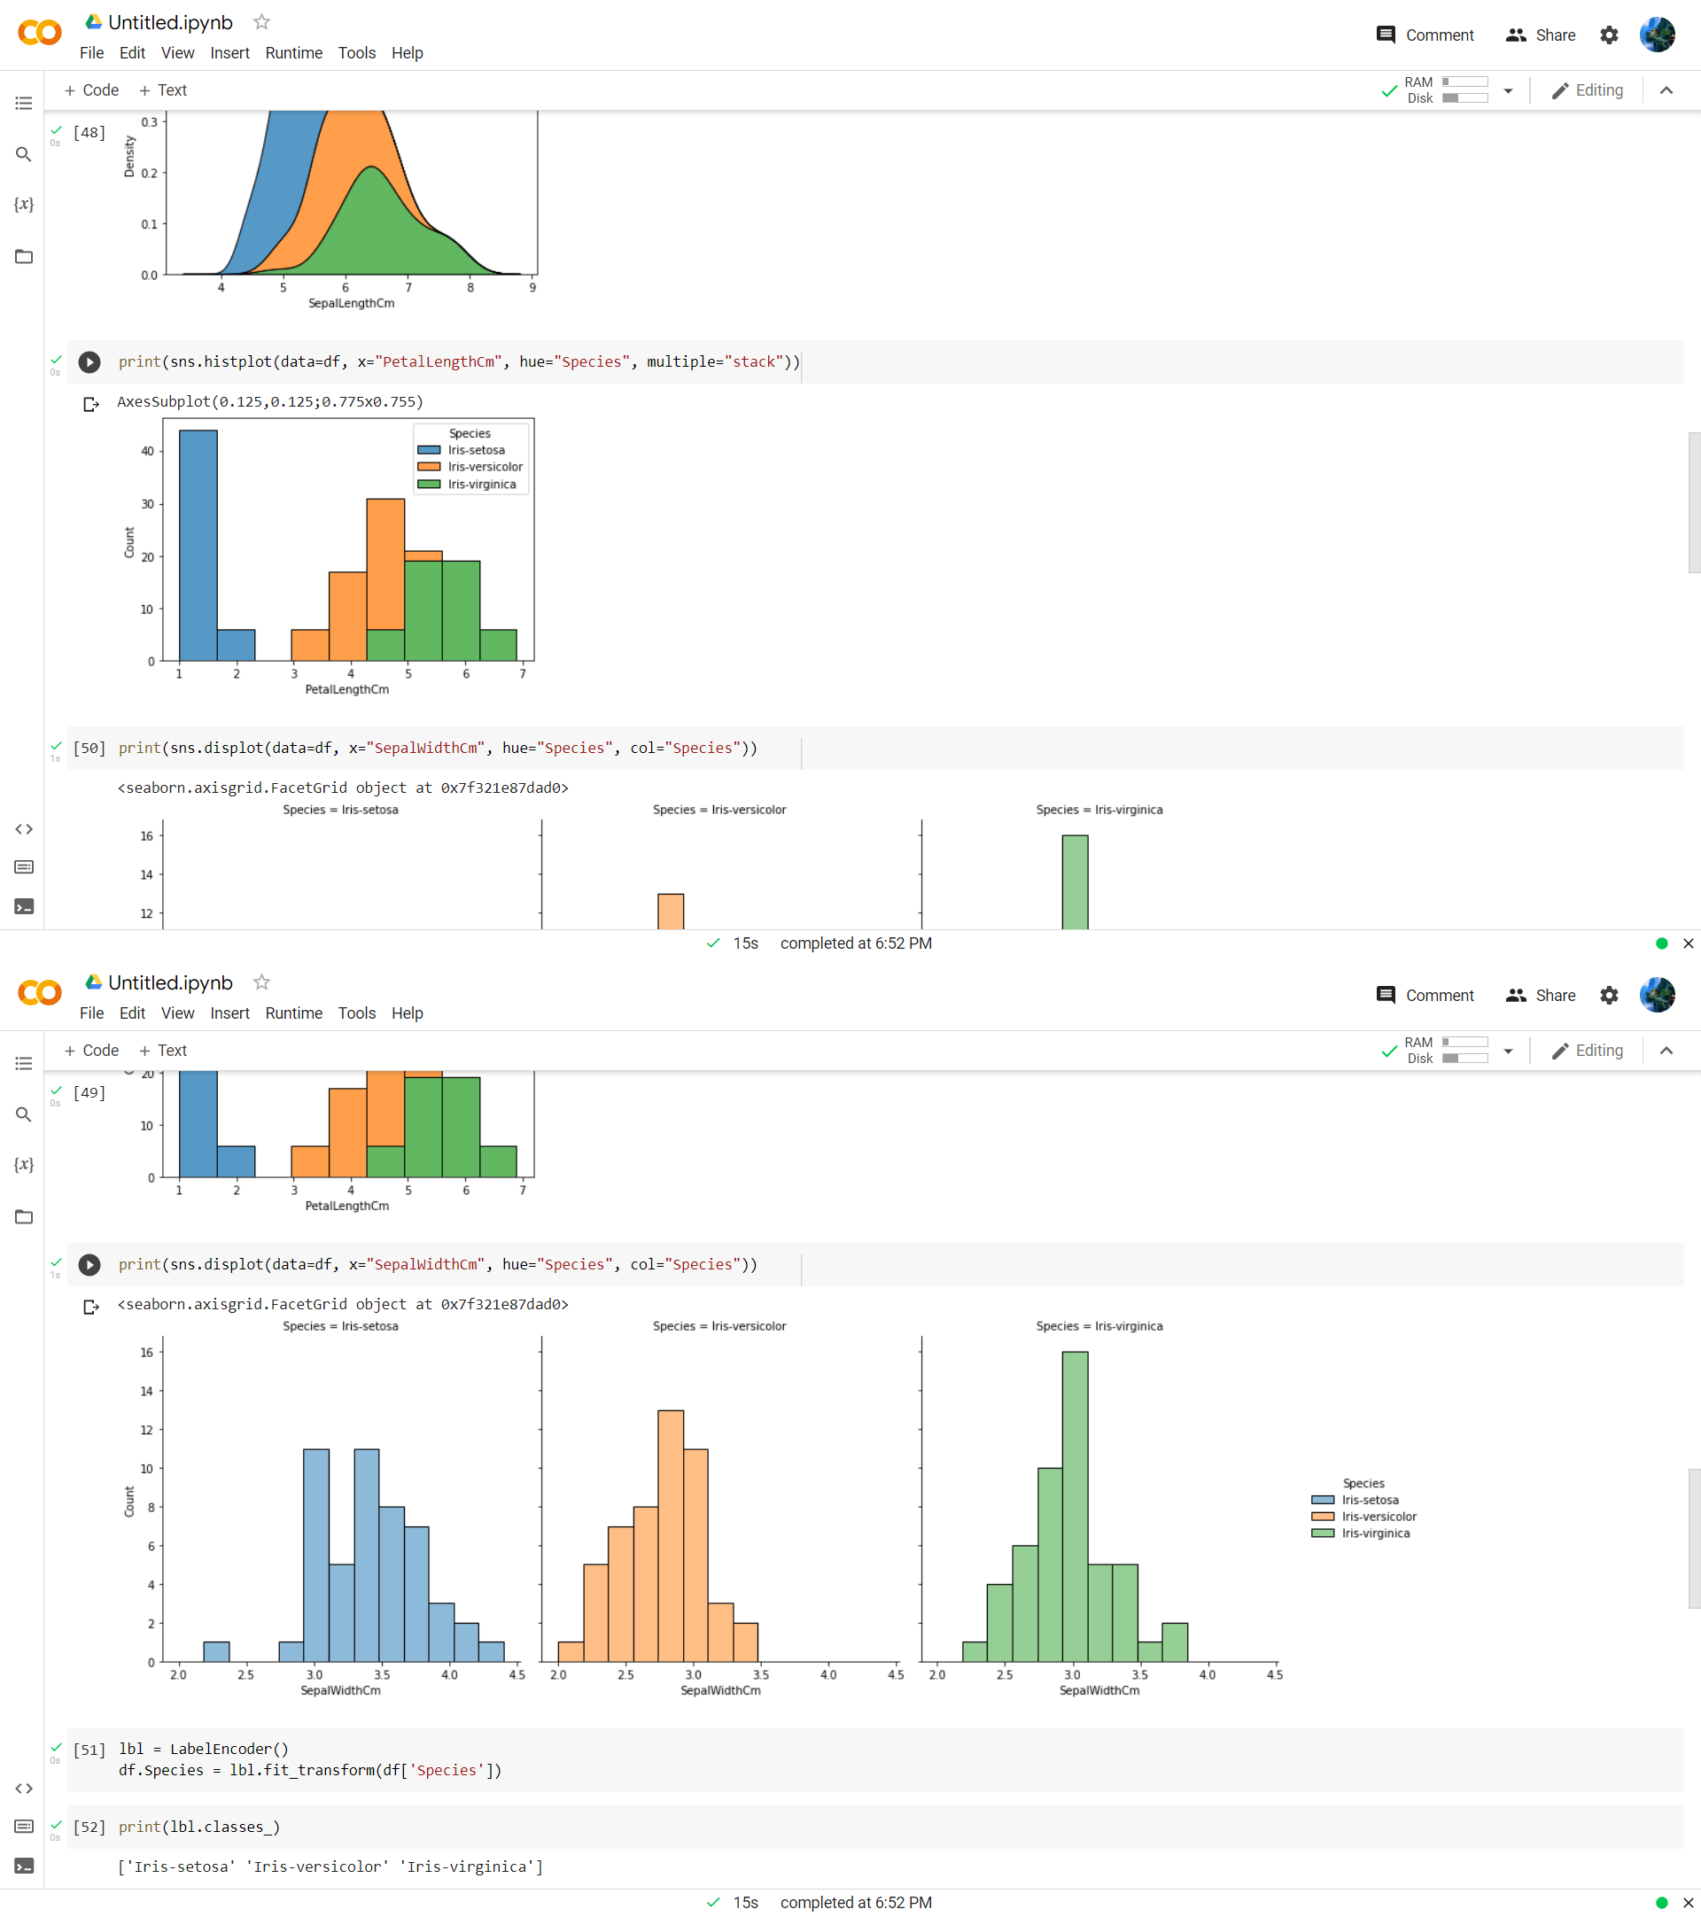

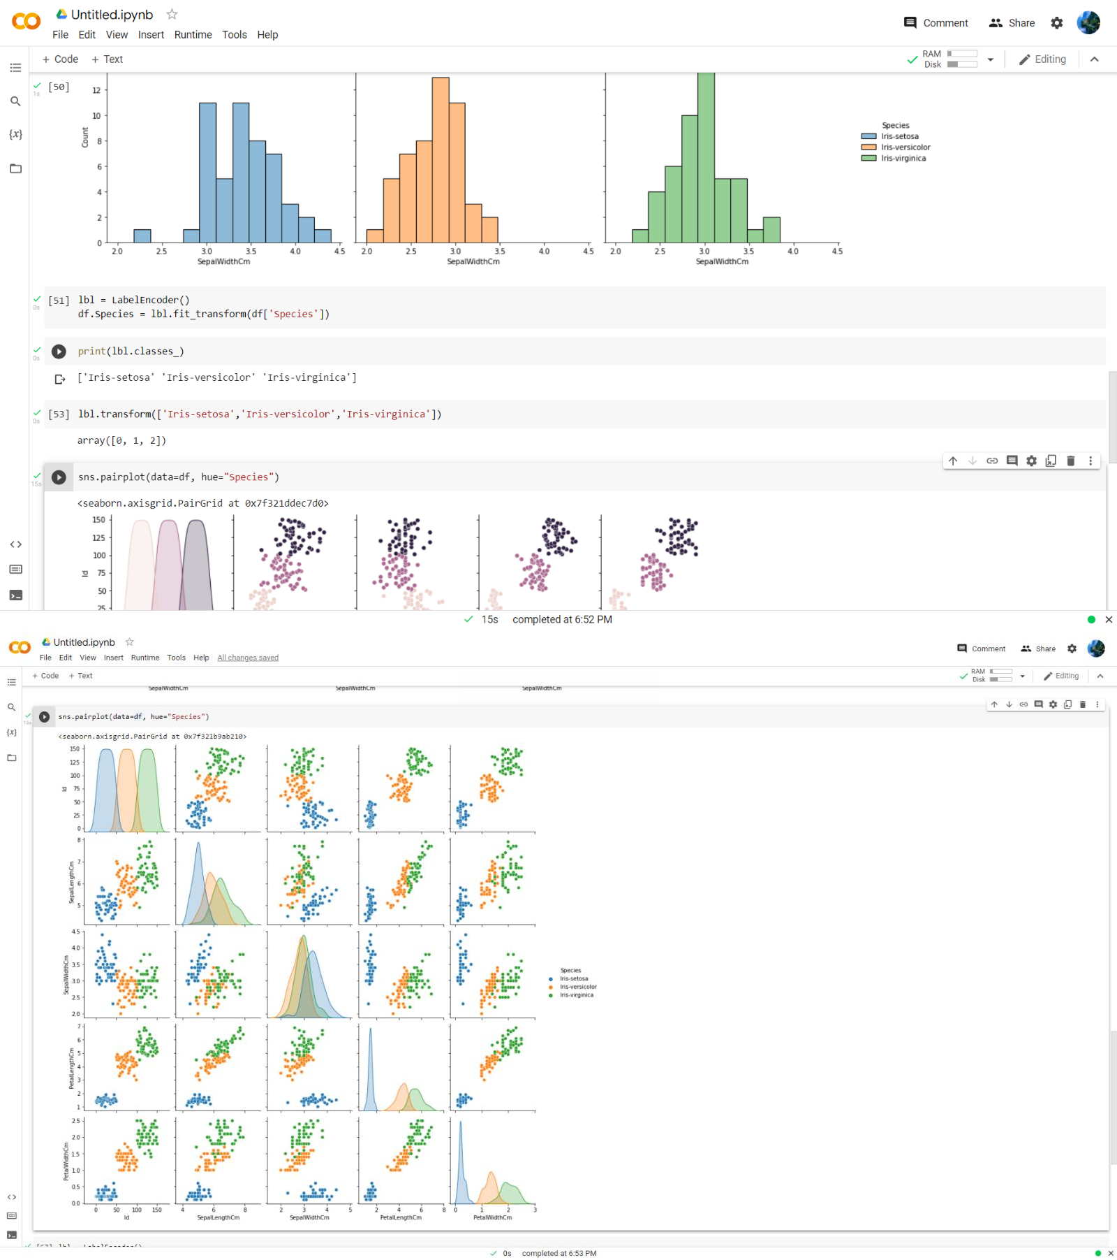

**Conclusion:**

Thus we have successfully installed Anaconda on windows and Ubuntu; We also have described the libraries and the installation of the libraries.

**Assignment 2**

**Aim:** Download any dataset from any data repositories and perform the basic data pre-processing steps

## Objectives:

1. Learn to pre-process dataset
2. Learn to use pandas and sklearn

## Theory:

**Basic steps to pre-process a dataset:**

Step 1. Import the libraries Step 2. Import the data-set

Step 3. Check out the missing values Step 4. See the Categorical Values

Step 5. Splitting the data-set into Training and Test Set

## Data cleaning:

* The main aim of Data Cleaning is to identify and remove errors & duplicate data, in order to create a reliable dataset.
* This improves the quality of the training data for analytics and enables accurate decision-making.
* There are various methods to identify and classify data for data cleansing.
* There are mainly two distinct techniques: **Qualitative and Quantitative** techniques to classify data errors.
  1. Qualitative techniques involve rules, constraints, and patterns to identify errors.
  2. Quantitative techniques employ statistical techniques to identify errors in the trained data.

## Feature Scaling:

Feature scaling is one of the most important data pre-processing steps in machine learning. Algorithms that compute the distance between the features are biased towards numerically larger values if the data is not scaled.

There are some feature scaling techniques such as Normalization and Standardization that are the most popular.

## Normalisation:

Normalization is a scaling technique in which values are shifted and rescaled so that they end up ranging between 0 and 1.

It is also known as Min-Max scaling.

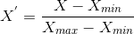

Here, Xmax and Xmin are the maximum and the minimum values of the feature respectively.

1. When the value of X is the minimum value in the column, the numerator will be 0, and hence X’ = 0
2. when the value of X is the maximum value in the column, the numerator is equal to the denominator and

thus the value of X’= 1

1. If the value of X is between the minimum and the maximum value, then the value of X’ is between 0 and 1

## Standardisation:

Standardization is another scaling technique where the values are centered around the mean with a unit standard deviation.

This means that the mean of the attribute becomes zero and the resultant distribution has a unit standard deviation.

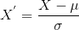

μ is the mean of the feature values and is the standard deviation of the feature values. The values are not restricted to a particular range.

## Data Encoding:

Encoding is a technique of converting categorical variables into numerical values so that it could be easily fitted to a machine learning model.

1. One Hot Encoding
2. Nominal Categorical Variable
3. Ordinal Categorical Variable
4. Label Encoding
5. Mean Encoding

## Code and Output:

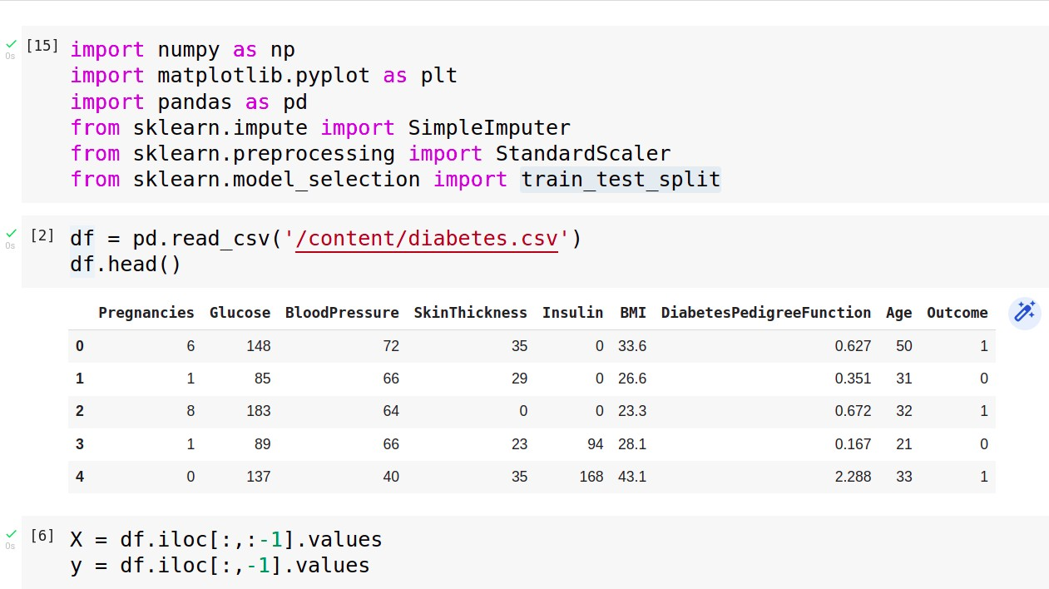

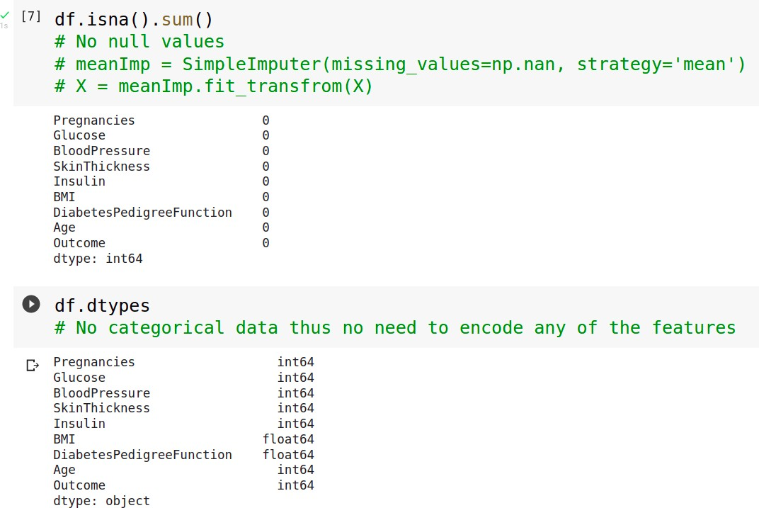

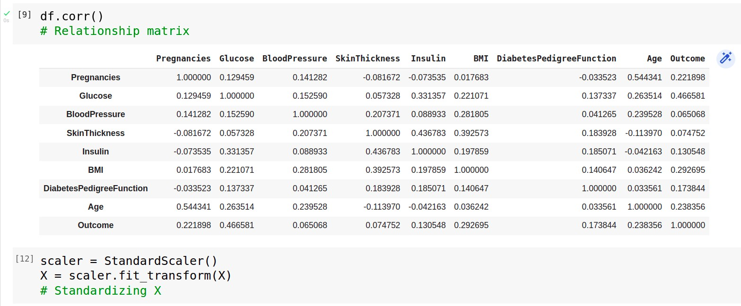

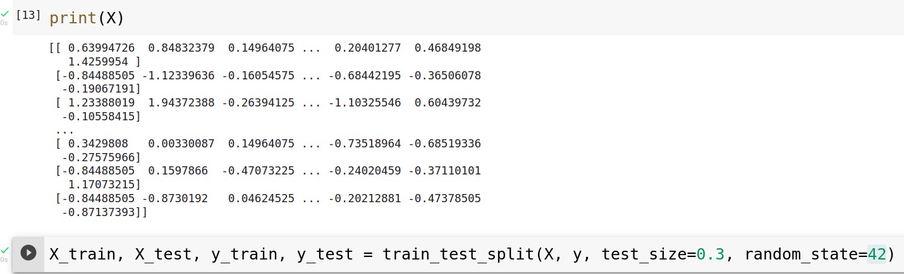

**Conclusion:**

Thus we have successfully implemented pre-processing operations on a dataset

**Assignment 3**

**Aim:** Download any dataset from UCI or Data.org or from any other data repositories and Implement Single and multilayer perceptron on a dataset.

## Objectives:

1. To learn about classification and regression
2. To learn MLP and backpropagation
3. To demonstrate and analyse the results

## Theory:

* **Regression:**

⇒ A regression problem is when the output variable is a real or continuous value, such as “salary” or “weight”.

⇒ Many different models can be used, the simplest is linear regression. It tries to fit data with the best hyper-plane which goes through the points.

## Classification:

⇒ A classification problem is when the output variable is a category, such as “red” or “blue” or “disease” and “no disease”.

⇒ A classification model attempts to draw some conclusion from observed values. Given one or more inputs a classification model will try to predict the value of one or more outcomes.

⇒ For example, when filtering emails “spam” or “not spam”, when looking at transaction data, “fraudulent”, or “authorized”.

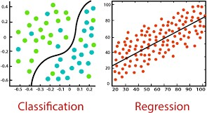

## Multilayer Perceptron:

⇒ In the Multilayer perceptron, there can be more than one linear layer (combinations of neurons). If we take the simple example the three-layer network,

* 1. The first layer will be the input layer
  2. The last layer will be output layer
  3. The middle layer will be called the hidden layer.

⇒ We feed our input data into the input layer and take the output from the output layer.

⇒ We can increase the number of the hidden layer as much as we want, to make the model more complex according to our task.

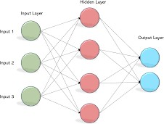

## Backpropagation Algorithm:

⇒ The algorithm is used to effectively train a neural network through a method called chain rule. In simple terms, after each forward pass through a network, backpropagation performs a backward pass while adjusting the model’s parameters (weights and biases).

⇒ Backpropagation aims to minimize the cost function by adjusting the network's weights and biases. The level of adjustment is determined by the gradients of the cost function with respect to those parameters.

## Activation function:

⇒ Activation functions, also known as non-linearity, describe the input-output relations in a non-linear way. This gives the model power to be more flexible in describing arbitrary relations.

⇒ Here are some popular activation functions: Sigmoid, Relu, TanH.

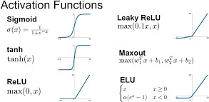

## Precision:

⇒ Precision is the ratio of correctly predicted positive observations to the total predicted positive observations.

## F1 score:

⇒ F1 Score is the weighted average of Precision and Recall. Therefore, this score takes both false positives and false negatives into account.

⇒ F1 is usually more useful than accuracy, especially if you have an uneven class distribution.

⇒ Accuracy works best if false positives and false negatives have similar cost. If the cost of false positives and false negatives are very different, it’s better to look at both

## Confusion matrix

⇒ A confusion matrix is a summary of prediction results on a classification problem.

⇒ The number of correct and incorrect predictions are summarized with count values and broken down by each class. This is the key to the confusion matrix.

⇒ The confusion matrix shows the ways in which your classification model is confused when it makes predictions. It gives us insight not only into the errors being made by a classifier but more importantly the types of errors that are being made.

## Code and Output:

1. **MLP Regressor:**

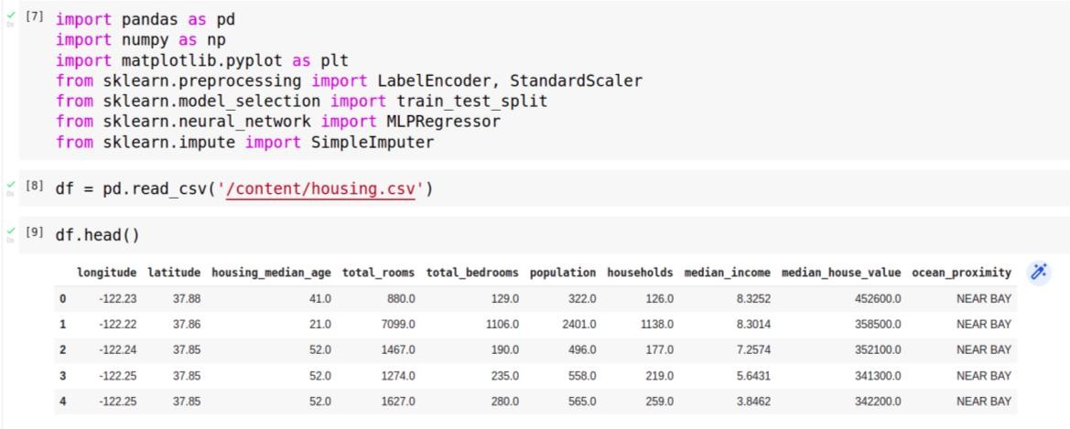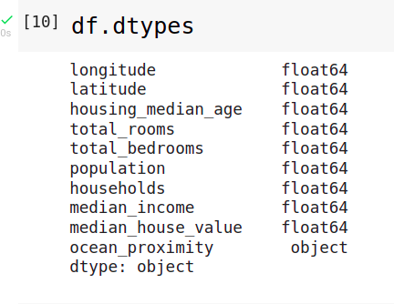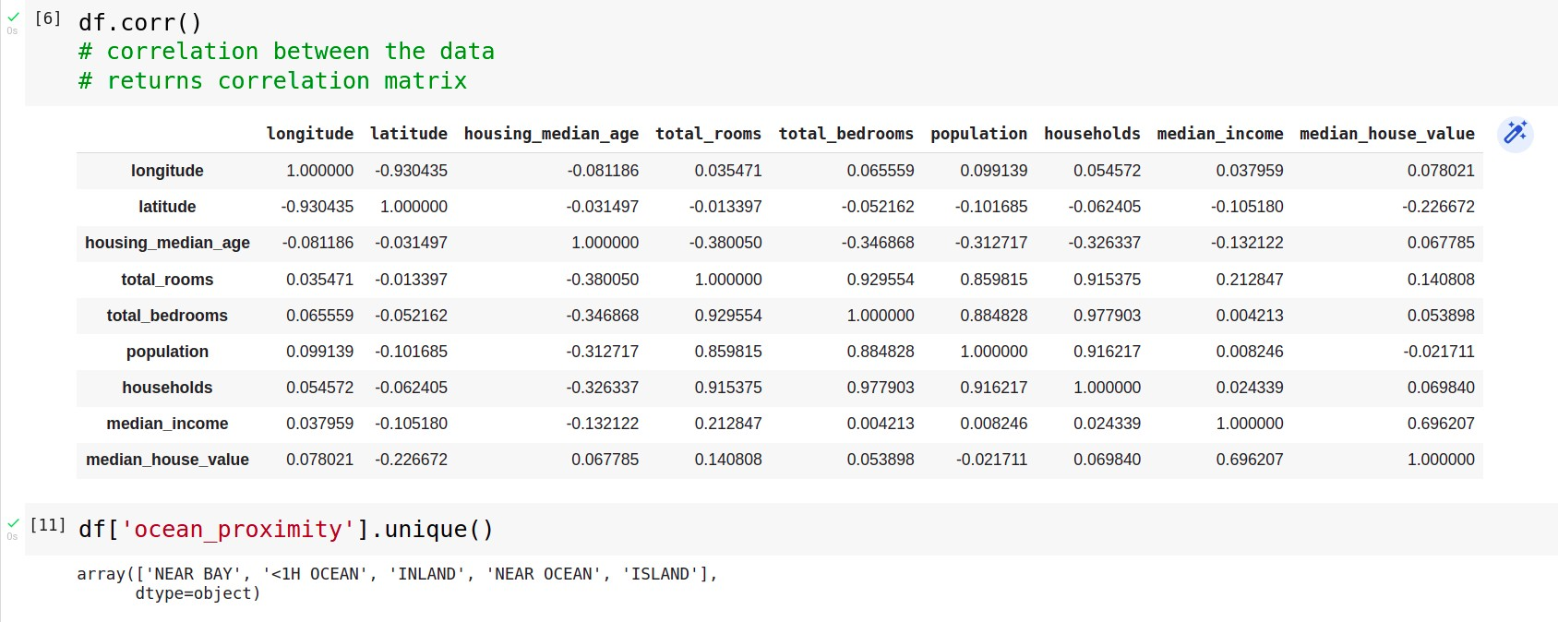

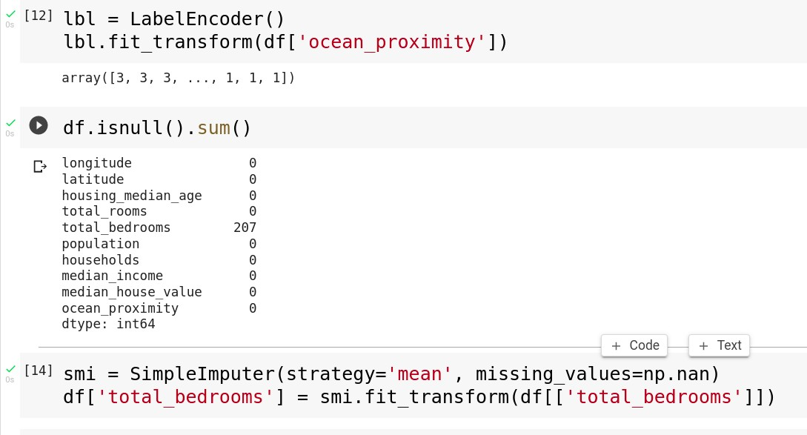

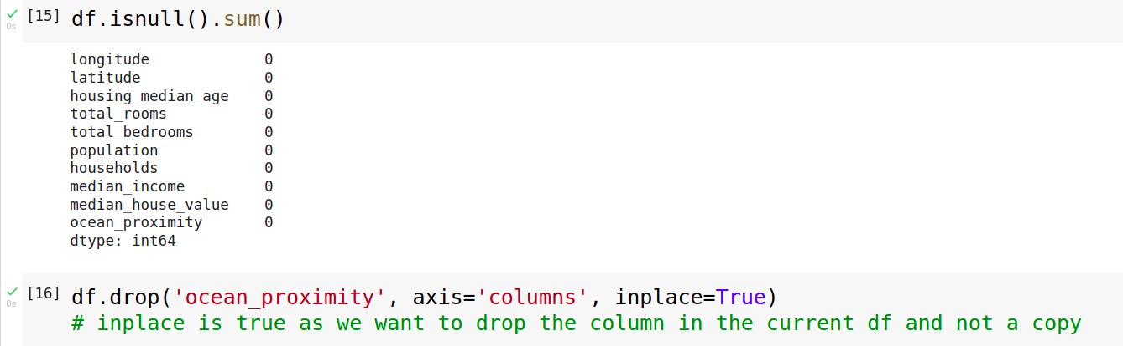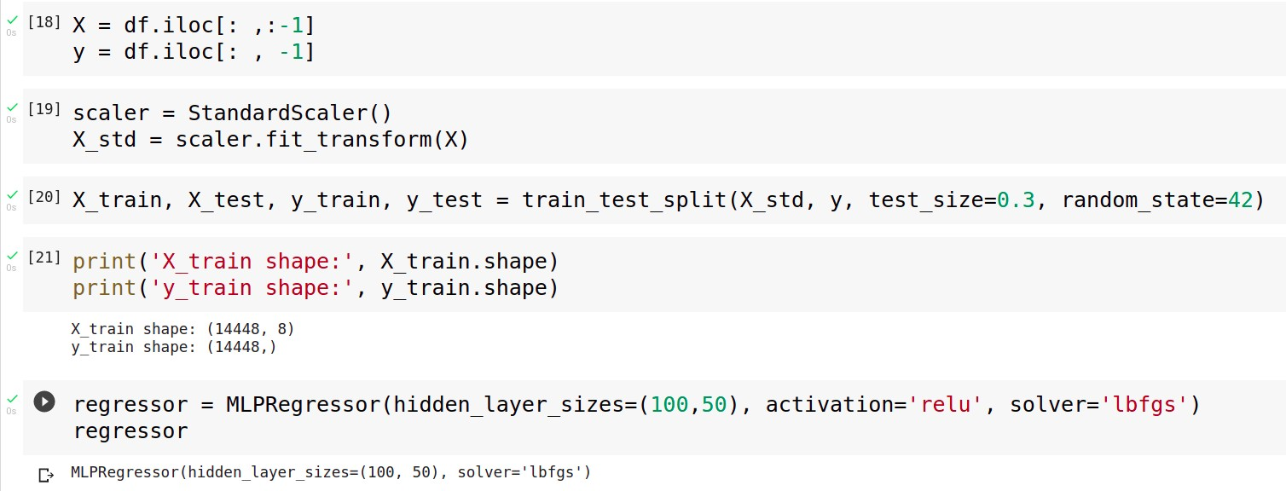

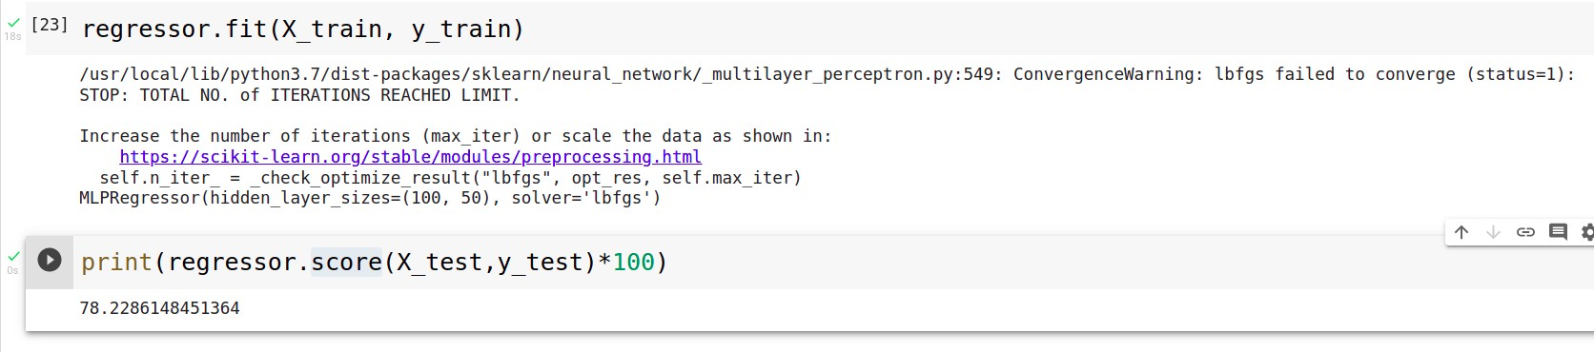

## MLP Classifier:

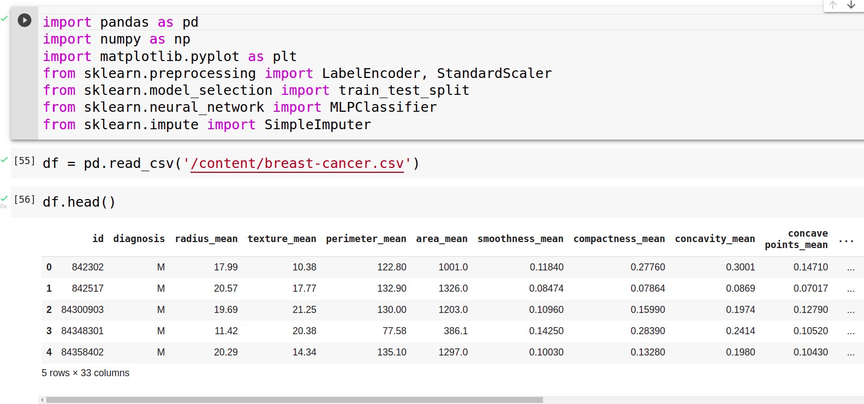

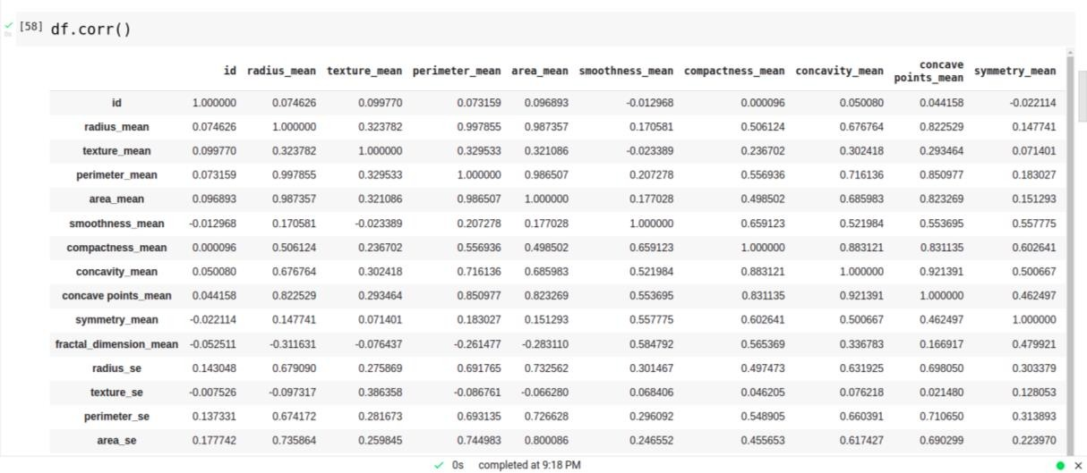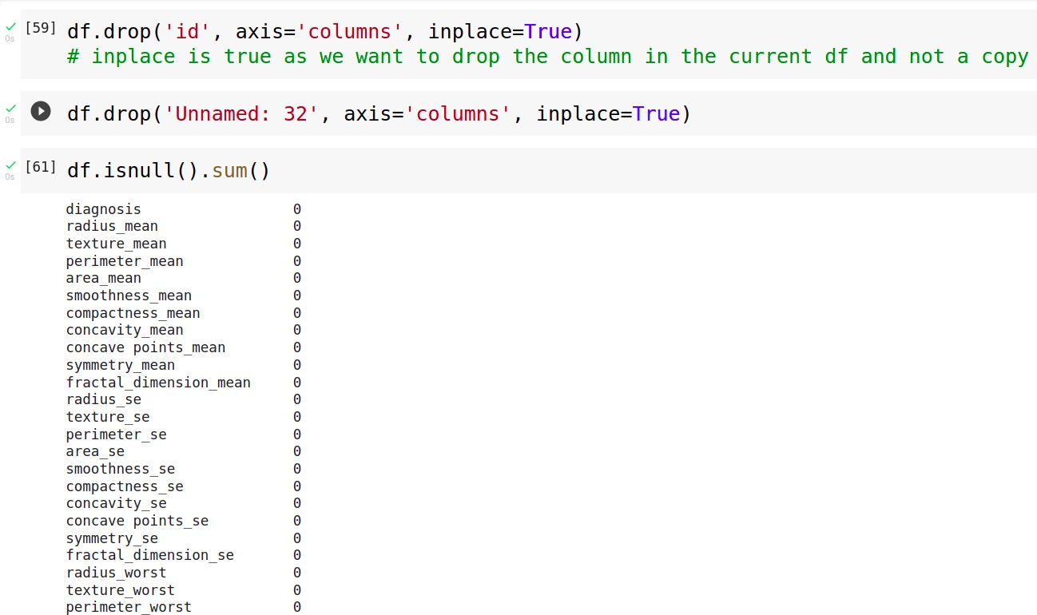

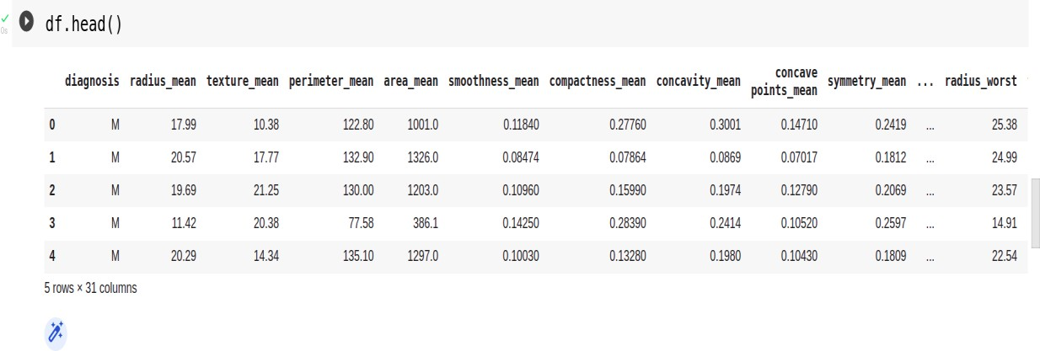

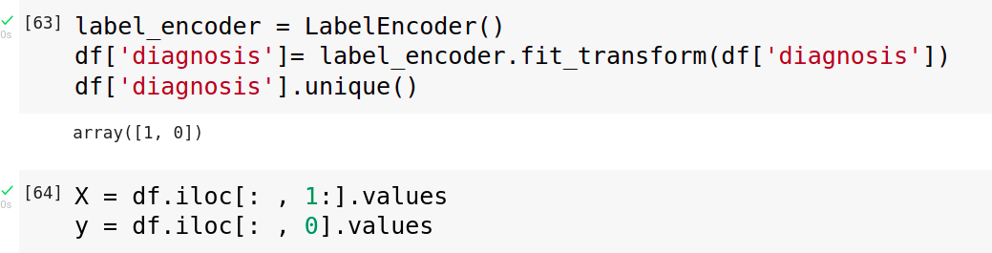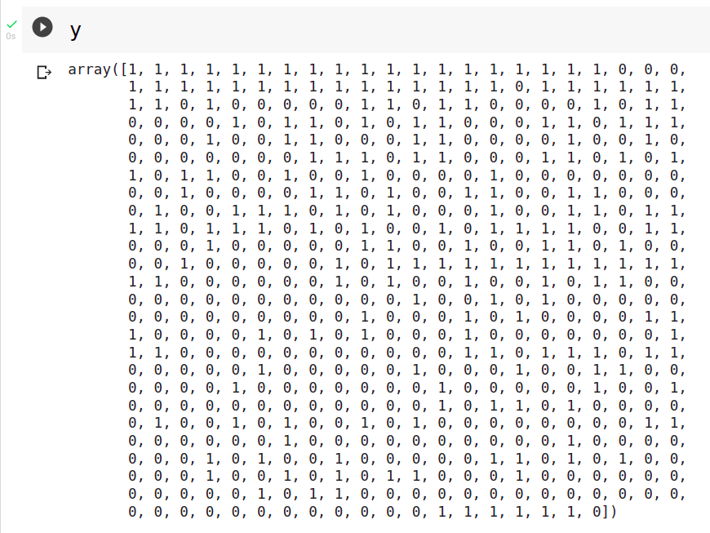

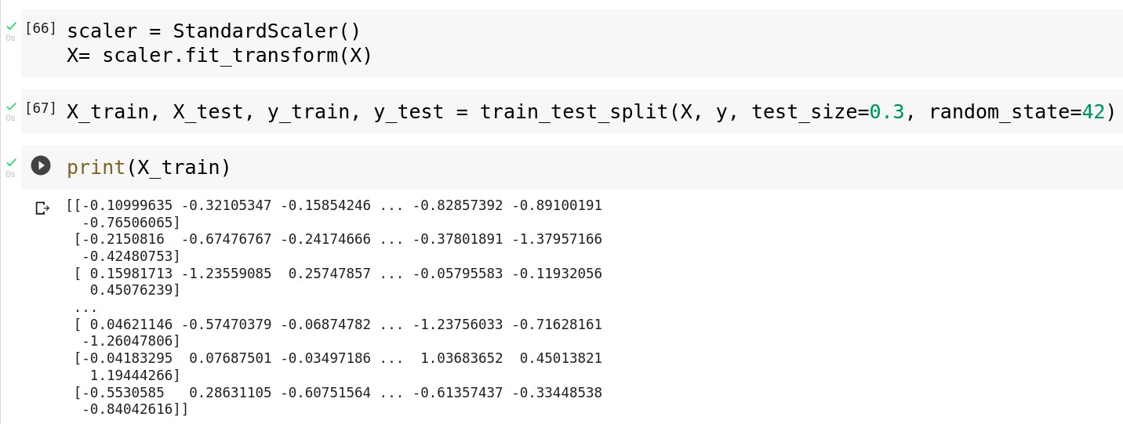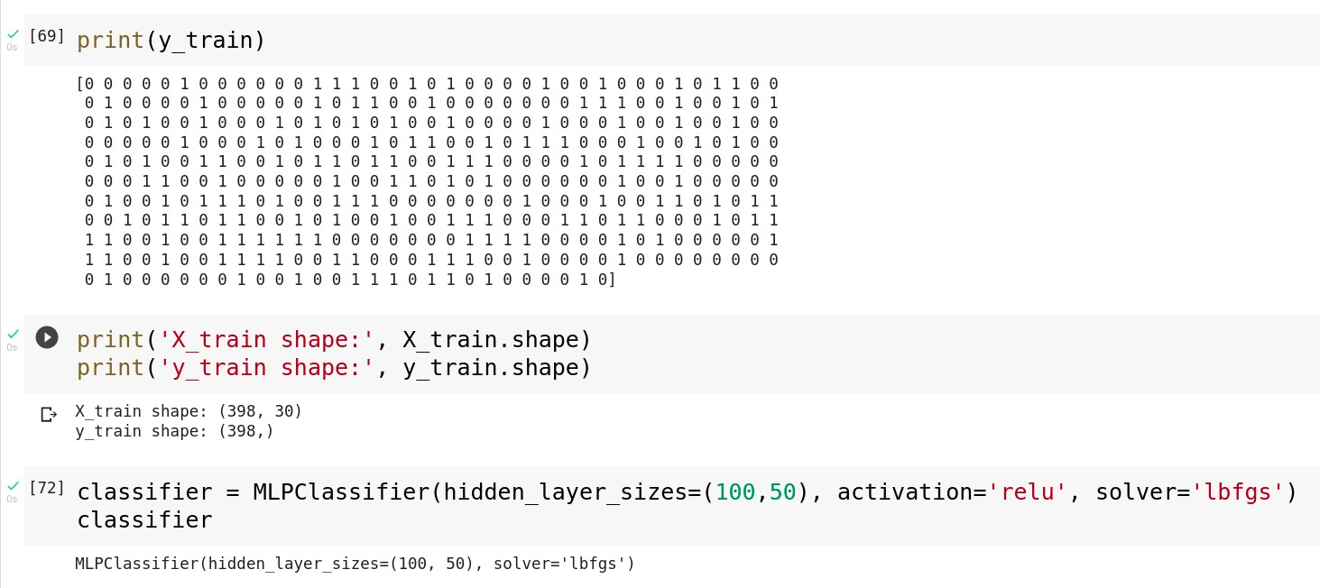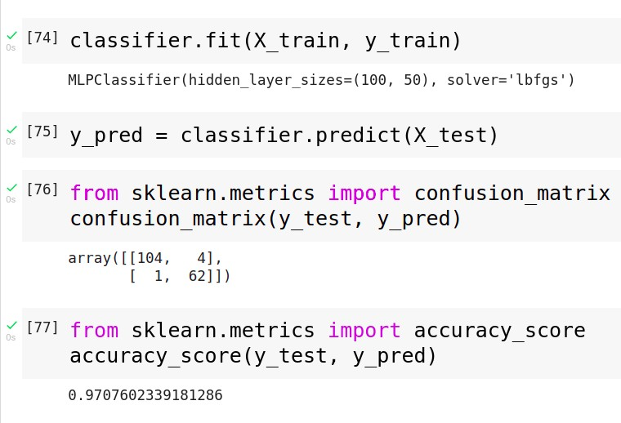

**Conclusion**

Thus we have successfully completed the implementation of Multilayer perceptron.

**Assignment 4**

**Aim:** Develop a Bayesian classifier on any dataset

## Objectives:

1. To learn bayes theorem
2. To implement Bayesian classifier

## Theory

* **Bayes Theorem**:

⇒ Bayes’ Theorem is a way of finding a probability when we know certain other probabilities.

⇒ Formula:



where A and B are events and P(B) ≠ 0.

⇒ Basically, we are trying to find the probability of event A, given that event B is true. Event B is also termed as evidence.

⇒ P(A) is the priori of A (the prior probability, i.e. Probability of event before evidence is seen). The evidence is an attribute value of an unknown instance (here, it is event B).

⇒ P(A|B) is a posteriori probability of B, i.e. probability of event after evidence is seen.

* This tells us: how often A happens given that B happens, written P(A|B),
* When we know: how often B happens given that A happens, written P(B|A)
* and how likely A is on its own, written P(A)
* and how likely B is on its own, written P(B)

## Bayesian classifier:

⇒ A Bayesian classifier is a probabilistic model where the classification is a latent variable that is probabilistically related to the observed variables.

⇒ In machine learning, naïve Bayes classifiers are a family of simple "probabilistic classifiers" based on applying Bayes' theorem with strong (naïve) independence assumptions between the features.

⇒ They are among the simplest Bayesian network models, and they could be coupled with Kernel density estimation and achieve higher accuracy levels.

## Code and Output:

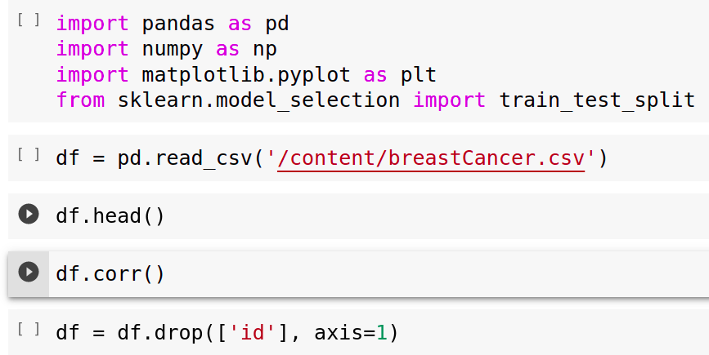

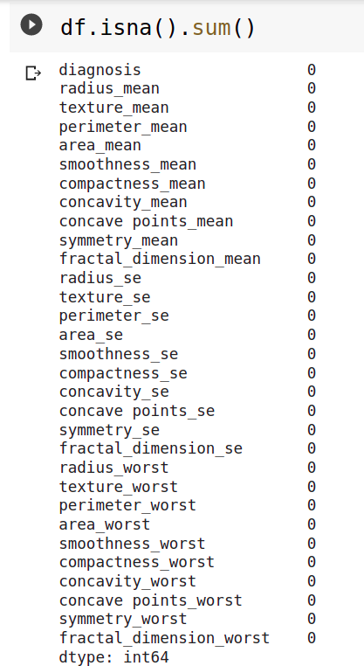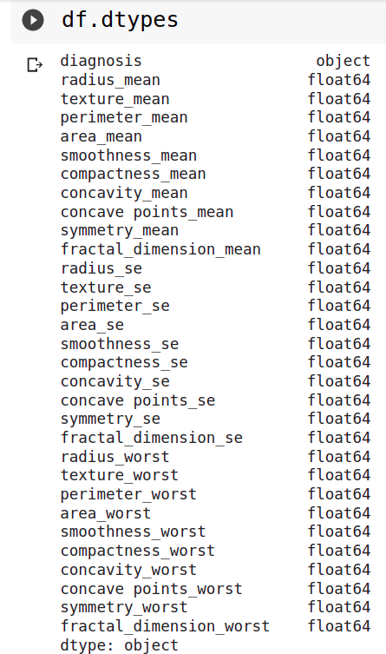

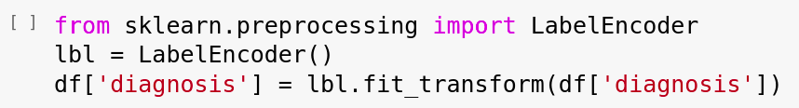

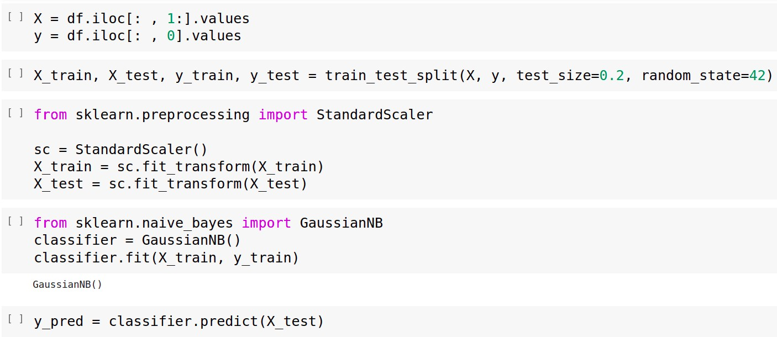

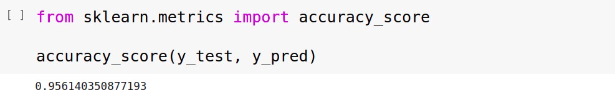

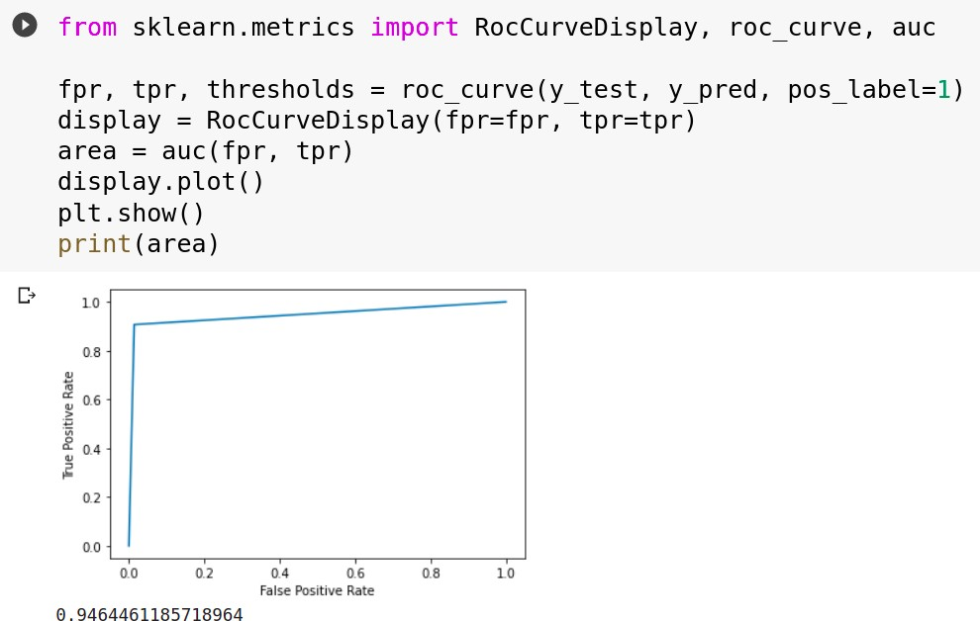

**Conclusion:**

Thus, we have successfully completed the implementation of Naïve Bayes Gaussian Classifier.

**Assignment 5**

**Aim:** Implement SVM Classifier or Regression for given dataset

## Objectives:

1. To learn SVM and kernel functions
2. To implement SVM classifier

## Theory:

* **SVM:**

⇒ support-vector machines (SVMs, also support-vector networks) are supervised learning models with associated learning algorithms that analyse data used for classification and regression analysis.

⇒ Given a set of training examples, each marked as belonging to one or the other of two categories, an SVM training algorithm builds a model that assigns new examples to one category or the other, making it a non- probabilistic binary linear classifier.

⇒ An SVM model is a representation of the examples as points in space, mapped so that the examples of the separate categories are divided by a clear gap that is as wide as possible.

⇒ New examples are then mapped into that same space and predicted to belong to a category based on the side of the gap on which they fall.

⇒ In addition to performing linear classification, SVMs can efficiently perform a non-linear classification using what is called the kernel trick, implicitly mapping their inputs into high-dimensional feature spaces.

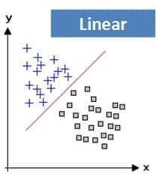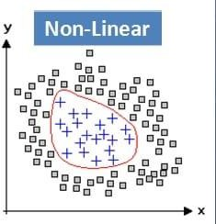

## Kernel function:

⇒ **Kernel Function** is a method used to take data as input and transform it into the required form of processing data.

⇒ Kernel Function generally transforms the training set of data so that a non-linear decision surface is able to transform to a linear equation in a higher number of dimension spaces.

⇒ Major Kernel Functions:

* 1. Gaussian Kernel
  2. Gaussian Kernel Radial Basis Function (RBF)
  3. Sigmoid Kernel
  4. Polynomial Kernel
  5. Linear Kernel

## Kernel trick

⇒ A Kernel Trick is a simple method where a Non Linear data is projected onto a higher dimension space so as to make it easier to classify the data where it could be linearly divided by a plane.

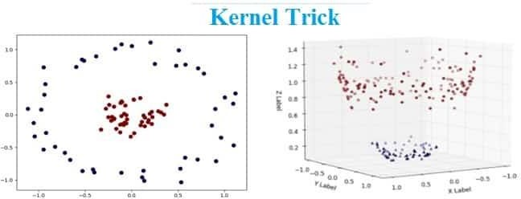

## Significance of SVM

⇒ It is capable of doing both classification and regression.

⇒ By presenting the problem in terms of the support vectors. we can apply the kernel trick to effectively transform the SVM into a non-linear classifier.

⇒ SVM works relatively well when there is a clear margin of separation between classes.

⇒ SVM is more effective in high dimensional spaces.

⇒ SVM is effective in cases where the number of dimensions is greater than the number of samples.

⇒ SVM is relatively memory efficient.

⇒ Non-linear SVM means that the boundary that the algorithm calculates doesn't have to be a straight line. The benefit is that you can capture much more complex relationships between your data-points without having to perform difficult transformations on your own.

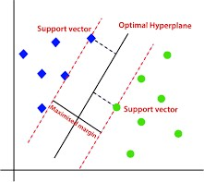

## Code and Output:

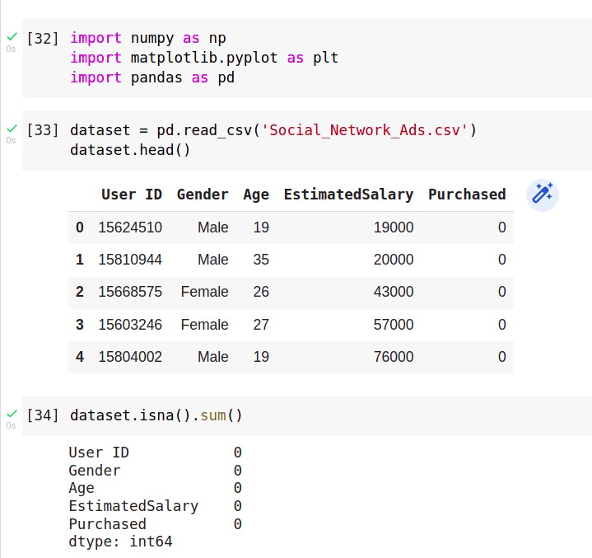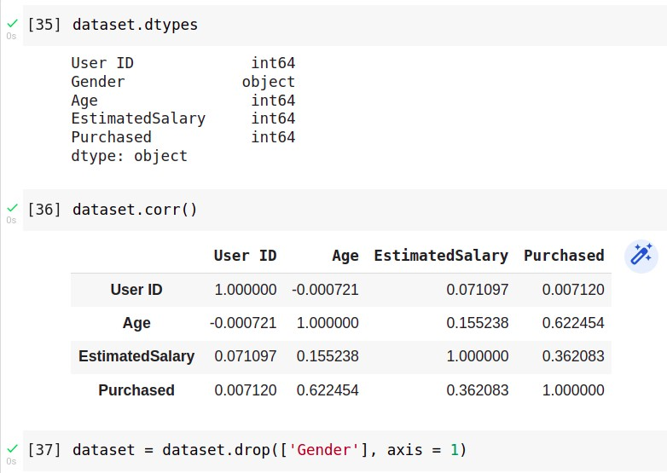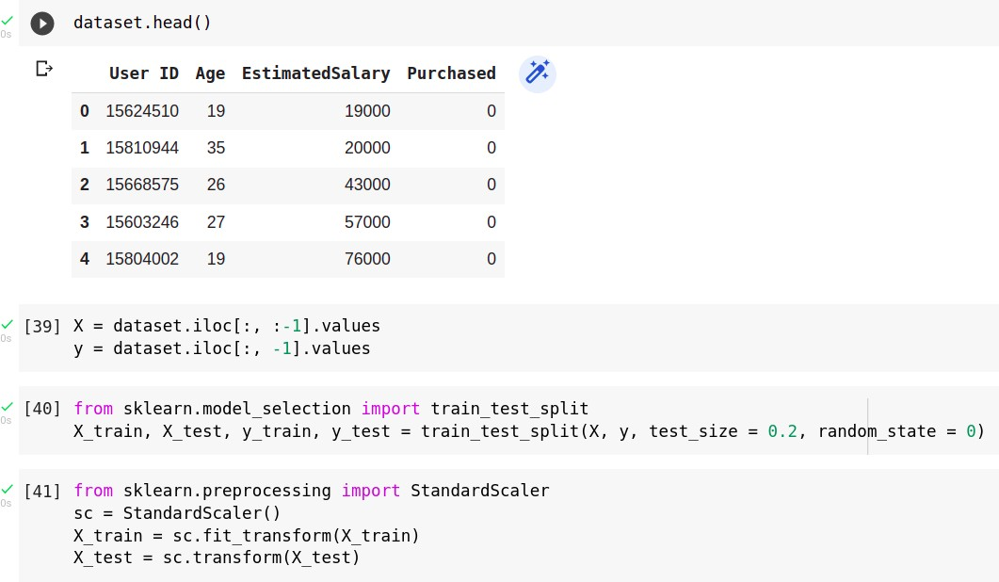

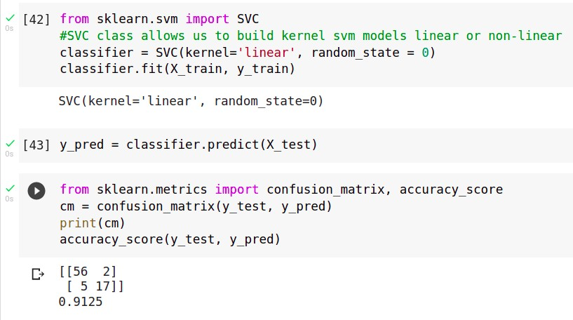

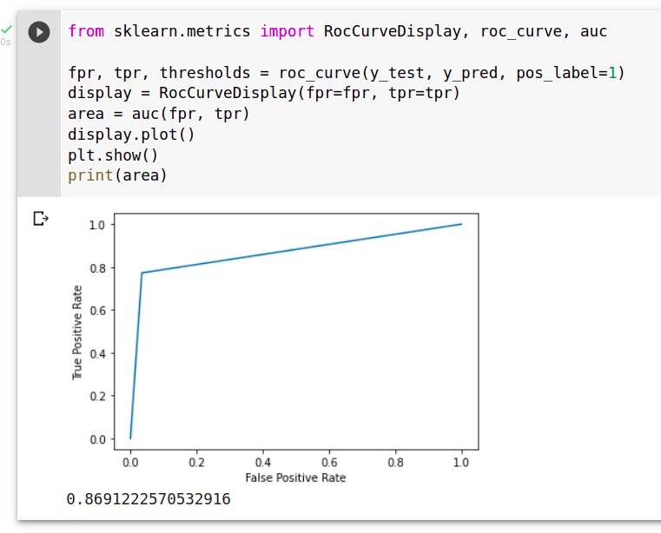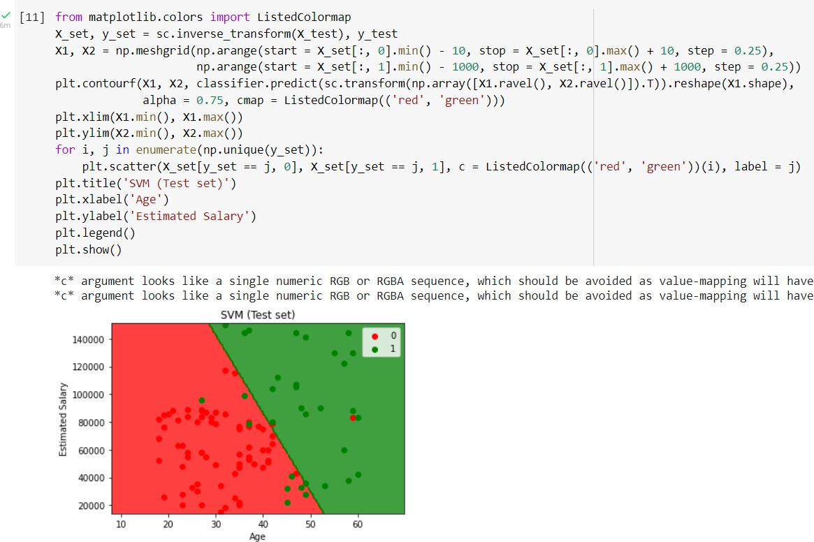

**Conclusion:**

Thus we have successfully completed the implementation of Support Vector Machine

**Assignment 6**

**Aim:** Using inbuilt datasetof breast cancer from scikit learn Implementation of PCA algorithm.

## Objectives:

1. To learn about dimensionality reduction techniques
2. To implement principal component analysis

## Theory:

* **Curse of Dimensionality:**

⇒ The curse of dimensionality refers to various phenomena that arise when analysing and organizing data in high- dimensional spaces (often with hundreds or thousands of dimensions) that do not occur in low-dimensional settings such as the three-dimensional physical space of everyday experience.

⇒ The expression was coined by Richard E. Bellman when considering problems in dynamic programming.

## Principal Component Analysis (PCA):

⇒ Given a collection of points in two, three, or higher dimensional space, a "best fitting" line can be defined as one that minimizes the average squared distance from a point to the line.

⇒ The next best-fitting line can be similarly chosen from directions perpendicular to the first.

⇒ Repeating this process yields an orthogonal basis in which different individual dimensions of the data are uncorrelated. These basis vectors are called principal components, and several related procedures principal component analysis (PCA).

##  Aims to find components that account for maximum variance in the data

⇒ PCA is mostly used as a tool in exploratory data analysis and for making predictive models.

⇒ It is often used to visualize genetic distance and relatedness between populations.

⇒ PCA is either done in the following 2 steps:

* calculating the data covariance (or correlation) matrix of the original data
* performing eigenvalue decomposition on the covariance matrix

## Linear discriminant analysis (LDA):

⇒ Linear discriminant analysis (LDA), normal discriminant analysis (NDA), or discriminant function analysis is a generalization of Fisher's linear discriminant, a method used in statistics, pattern recognition, and machine learning to find a linear combination of features that characterizes or separates two or more classes of objects or events.

⇒ The resulting combination may be used as a linear classifier, or, more commonly, for dimensionality reduction before later classification.

##  This method identifies components (i.e., linear combination of the observed variables) that maximize class separation (i.e., between-class variance)

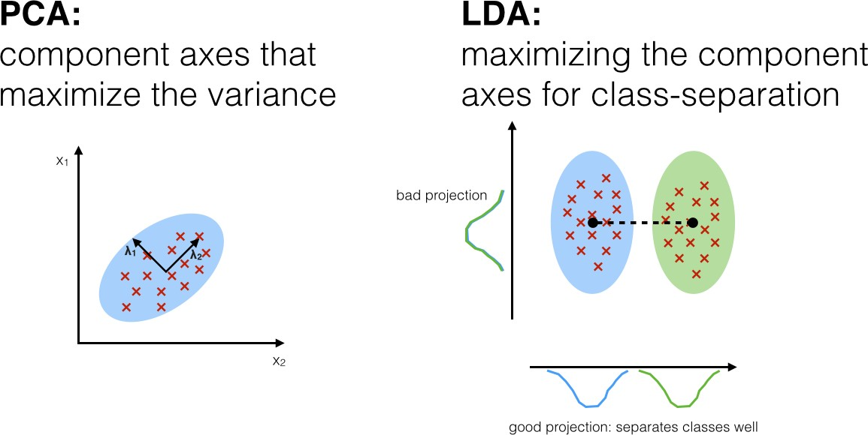

* **Steps of PCA:**

Step 1. Standardization

Step 2. Covariance Matrix Computation

Step 3. Compute the eigenvectors and eigenvalues of the covariance matrix to identify the principal components Step 4. Feature Vector

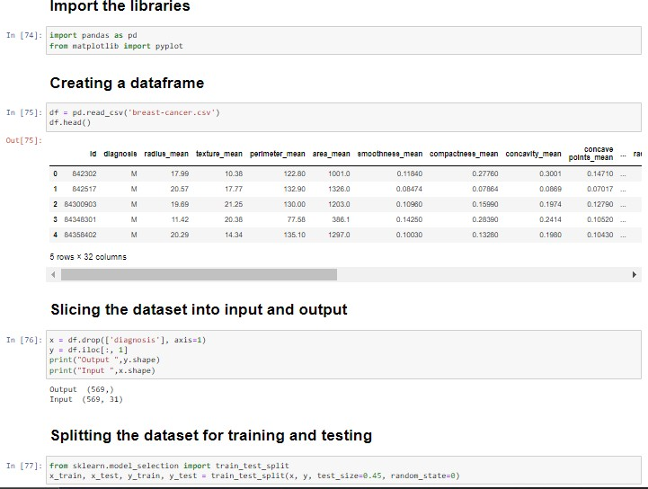**Code**

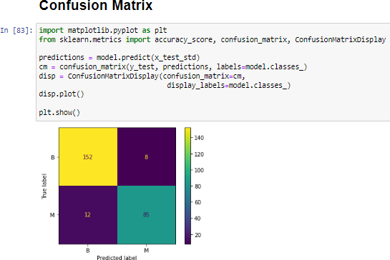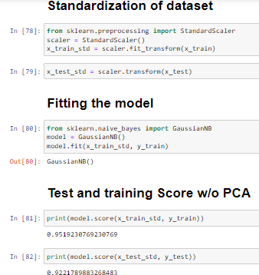

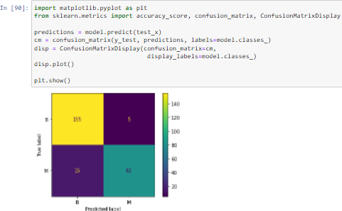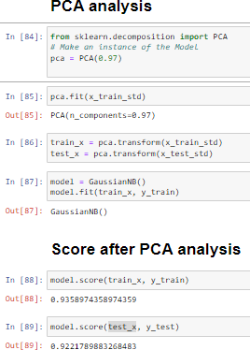

**Conclusion**

Thus we have successfully completed the implementation of Principal Component Analysis(PCA)

# 

# **Assignment 7**

**Aim:** Implement decision tree classification/regression technique for given dataset Developed model should be able to answer the given queries.

**Objectives:**

1. **To learn about decision trees**
2. **To implement decision trees and compare results**

## Theory:

* **Decision Tree:**

⇒ Decision tree is the most powerful and popular tool for classification and prediction.

⇒ A Decision tree is a flowchart like tree structure, where each internal node denotes a test on an attribute, each branch represents an outcome of the test, and each leaf node (terminal node) holds a class label.

⇒ A tree can be “learned” by splitting the source set into subsets based on an attribute value test. This process is repeated on each derived subset in a recursive manner called recursive partitioning. The recursion is completed when the subset at a node all has the same value of the target variable, or when splitting no longer adds value to the predictions.

⇒ Decision trees can handle high dimensional data. In general decision tree classifier has good accuracy.

⇒ Decision tree induction is a typical inductive approach to learn knowledge on classification.

## Decision trees used in data mining are of two main types:

⇒ Classification tree analysis is when the predicted outcome is the class (discrete) to which the data belongs.

⇒ Regression tree analysis is when the predicted outcome can be considered a real number (e.g. the price of a house, or a patient's length of stay in a hospital).

The term Classification And Regression Tree (CART) analysis is an umbrella term used to refer to both of the above procedures.

A special case of a decision tree is a **decision list**, which is a one-sided decision tree, so that every internal node has exactly 1 leaf node and exactly 1 internal node as a child (except for the bottommost node, whose only child is a single leaf node

## Notable decision tree algorithms include:

1. ID3 (Iterative Dichotomiser 3)
2. C4.5 (successor of ID3)
3. CART (Classification And Regression Tree)[4]
4. Chi-square automatic interaction detection (CHAID). Performs multi-level splits when computing classification trees.[12]
5. MARS: extends decision trees to handle numerical data better.
6. Conditional Inference Trees
7. Statistics-based approach that uses non-parametric tests as splitting criteria, corrected for multiple testing to avoid overfitting. This approach results in unbiased predictor selection and does not require pruning.

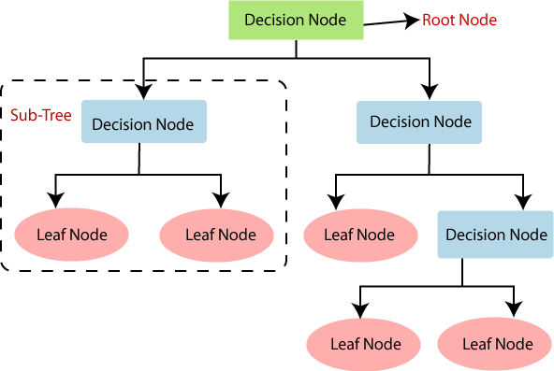

**Code**

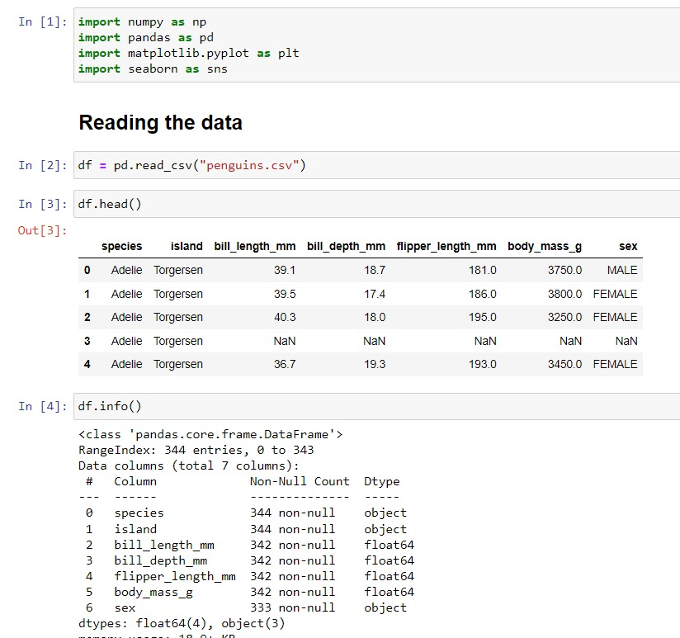

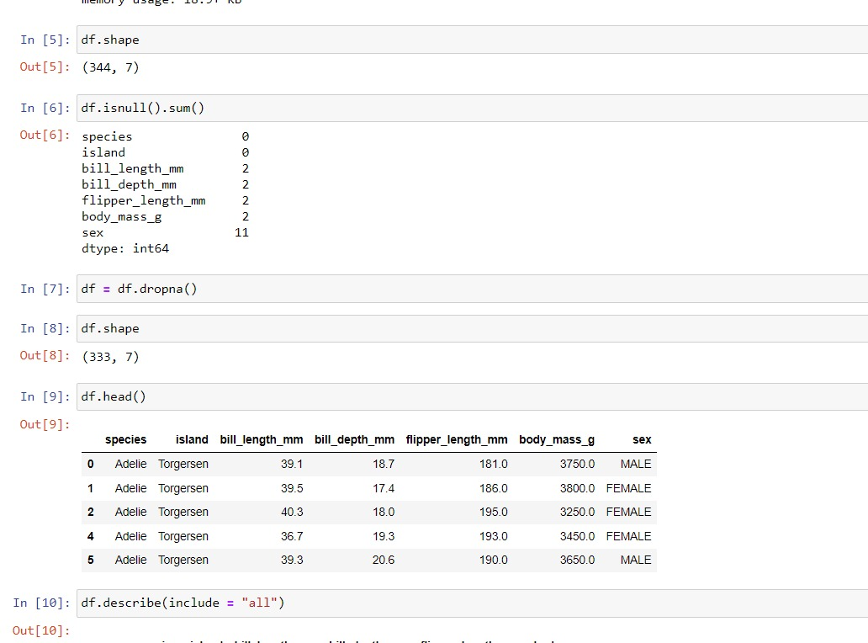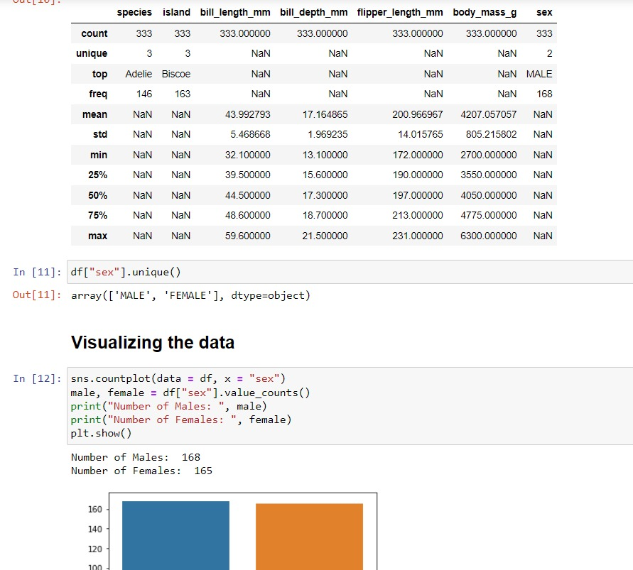

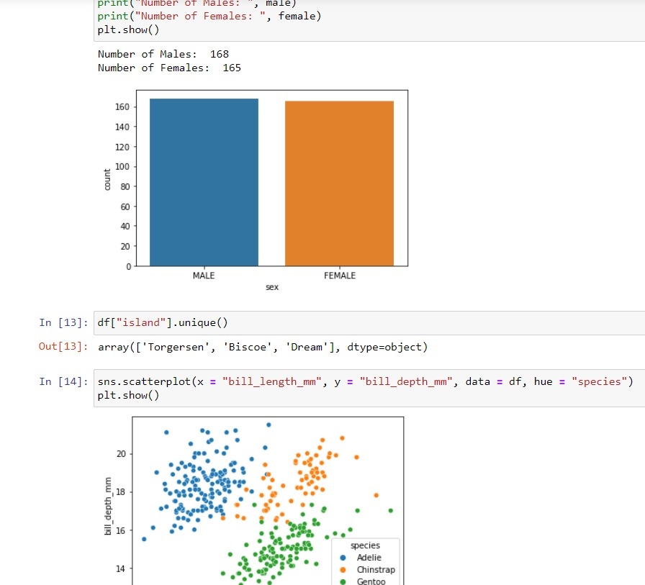

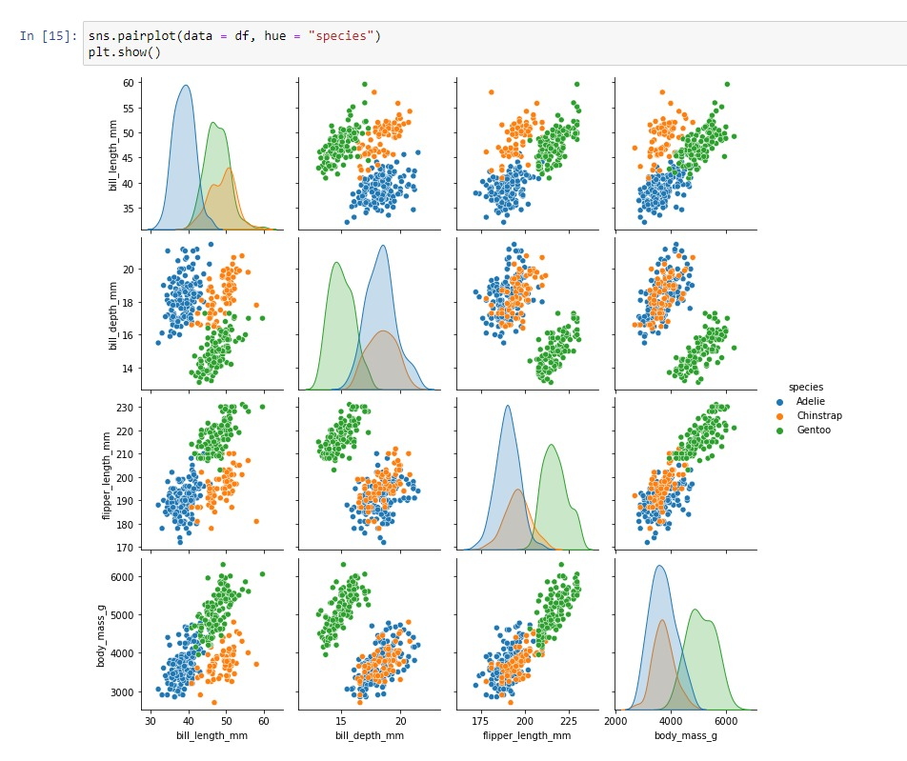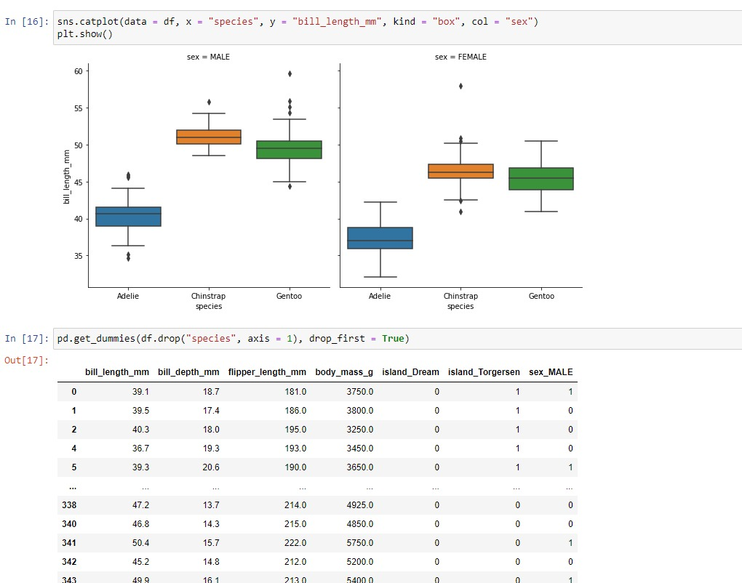

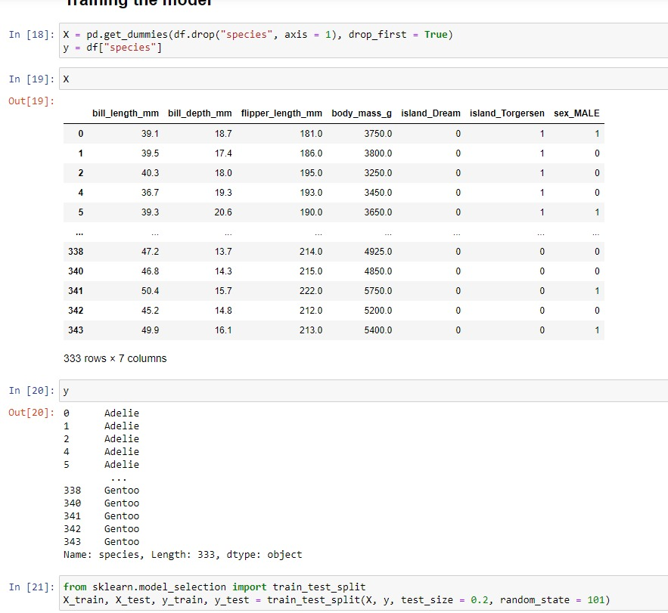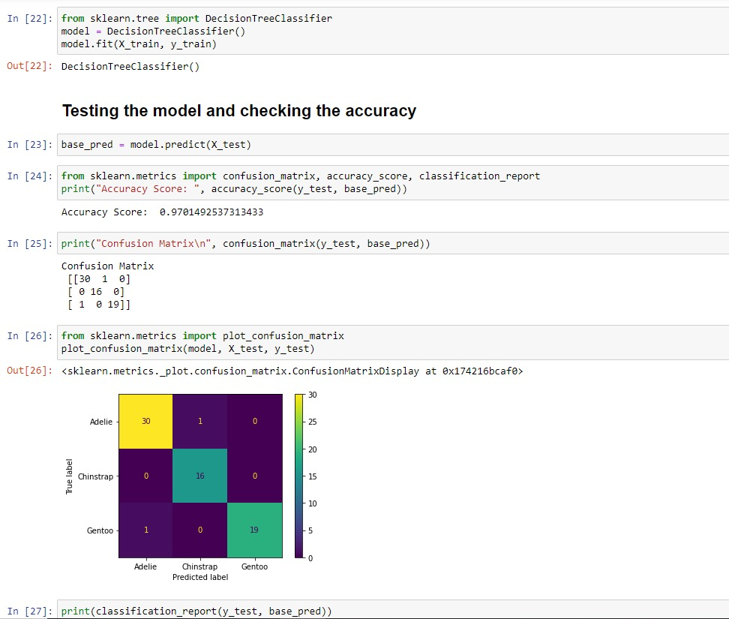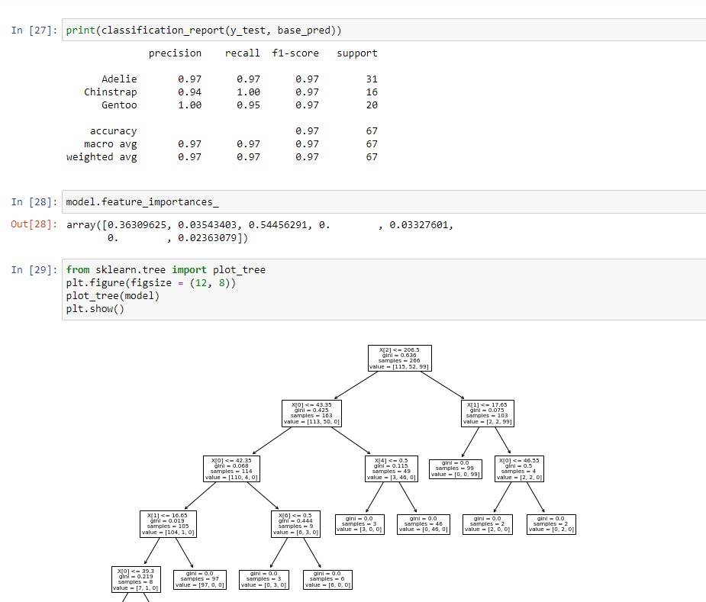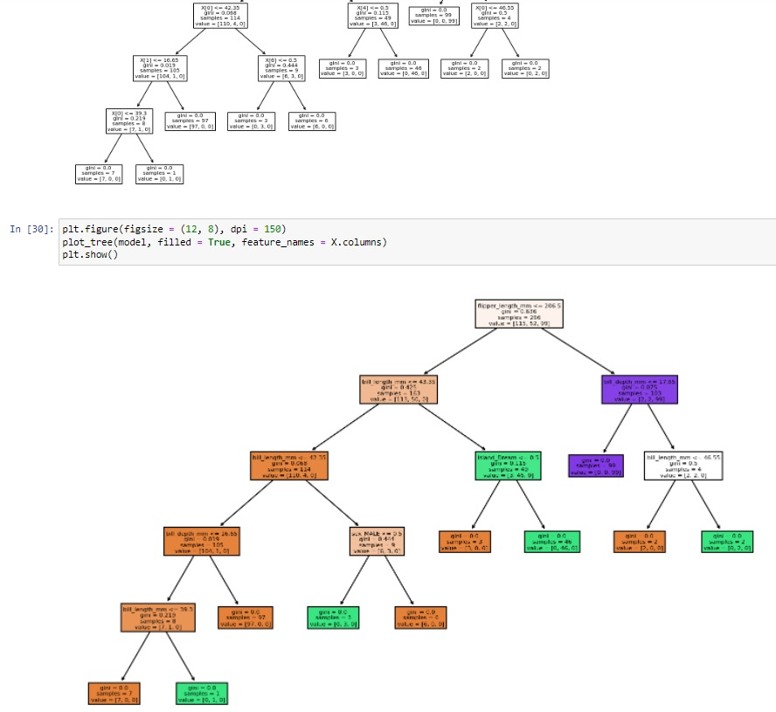

**Conclusion**

Thus we have successfully completed the implementation of decision tree classifier.

**Assignment 9**

**Aim:** Implement K means algorithm for multidimensional data for Cars or Wine dataset from UCI repository Objectives:

1. **To learn unsupervised learning**
2. **To implement K means algorithm**

## Theory:

* **Unsupervised learning :**

⇒ It is a type of machine learning algorithm used to draw inferences from datasets consisting of input data without labelled responses.

⇒ The most common unsupervised learning method is cluster analysis, which is used for exploratory data analysis to find hidden patterns or grouping in data.

⇒ Unsupervised learning methods are used in bioinformatics for sequence analysis and genetic clustering; in data mining for sequence and pattern mining; in medical imaging for image segmentation; and in computer vision for object recognition.

## Common clustering algorithms include:

⇒ **Hierarchical clustering**: builds a multilevel hierarchy of clusters by creating a cluster tree

⇒ **k-Means clustering**: partitions data into k distinct clusters based on distance to the centroid of a cluster

⇒ **Gaussian mixture models**: models clusters as a mixture of multivariate normal density components

⇒ **Self-organizing maps**: uses neural networks that learn the topology and distribution of the data

⇒ **Hidden Markov models**: uses observed data to recover the sequence of states

## K Means Clustering:

⇒ Clustering is the process of dividing the entire data into groups (also known as clusters) based on the patterns in the data.

⇒ In clustering, we do not have a target to predict. We look at the data and then try to club similar observations and form different groups. Hence it is an unsupervised learning problem.

⇒ The main objective of the K-Means algorithm is to minimize the sum of distances between the points and their respective cluster centroid.

**Step 1.** Choose the number of clusters k

**Step 2.** Select k random points from the data as centroids **Step 3.** Assign all the points to the closest cluster centroid **Step 4.** Recompute the centroids of newly formed clusters **Step 5.** Repeat steps 3 and 4

## Stopping Criteria for K-Means Clustering:

⇒ Centroids of newly formed clusters do not change

⇒ Points remain in the same cluster

⇒ Maximum number of iterations are reached

**K means algorithm**

Kmeans algorithm is an iterative algorithm that tries to partition the dataset into K pre-defined distinct non-overlapping subgroups (clusters) where each data point belongs to only one group. It tries to make the inter-cluster data points as similar as possible while also keeping the clusters as different (far) as possible. It assigns data points to a cluster such that the sum of the squared distance between the data points and the cluster’s centroid (arithmetic mean of all the data points that belong to that cluster) is at the minimum. The less variation we have within clusters, the more homogeneous (similar) the data points are within the same cluster.

**The way k means algorithm works is as follows:**

1. Specify number of clusters K.
2. Initialize centroids by first shuffling the dataset and then randomly selecting K data points for the centroids without replacement.
3. Keep iterating until there is no change to the centroids. i.e assignment of data points to clusters isn’t changing.

* Compute the sum of the squared distance between data points and all centroids.
* Assign each data point to the closest cluster (centroid).
* Compute the centroids for the clusters by taking the average of the all data points that belong to each cluster.

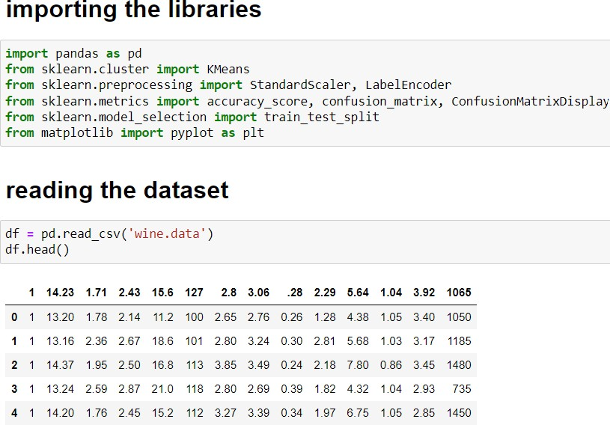**Code**

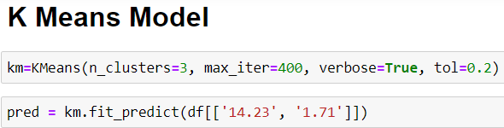

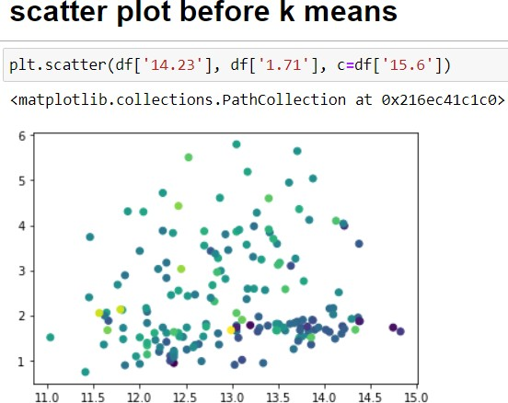

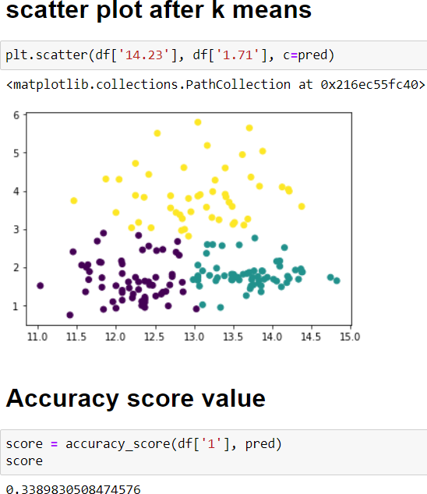

**Conclusion:**

Thus we have successfully completed the implementation of Kmeans algorithm.

**Assignment 10**

# **Aim:** Download the famous dataset of iris and Implement KNN algorithm to predict the class to which these plants belong, Calculate the performance matric and compare the error rate with K value( K value range).

**Objectives:**

1. To learn KNN algorithm
2. To implement KNN classifier

## Theory:

* **Lazy learners**

⇒ Lazy learners simply store the training data and wait until a testing data appear. When it does, classification is conducted based on the most related data in the stored training data. Compared to eager learners, lazy learners have less training time but more time in predicting.

1. Just store Data set without learning from it
2. Start classifying data when it receives Test data
3. So, it takes less time learning and more time classifying data

## Eager learners

⇒ Eager learners construct a classification model based on the given training data before receiving data for classification. It must be able to commit to a single hypothesis that covers the entire instance space. Due to the model construction, eager learners take a long time for train and less time to predict.

1. When it receives data set it starts classifying (learning)
2. Then it does not wait for test data to learn
3. It takes long time learning and less time classifying data

## KNN Algorithm

⇒ The KNN algorithm assumes that similar things exist in close proximity, similar things are near to each other.

⇒ The KNN algorithm hinges on this assumption being true enough for the algorithm to be useful. KNN captures the idea of similarity (sometimes called distance, proximity, or closeness) with some mathematics we might have learned in our childhood— calculating the distance between points on a graph.

## Algorithm:

1. Load the data
2. Initialize K to your chosen number of neighbours
   1. Calculate the distance between the query example and the current example from the data.
   2. Add the distance and the index of the example to an ordered collection
3. Sort the ordered collection of distances and indices from smallest to largest(in ascending order) by the distances
4. Pick the first K entries from the sorted collection
5. Get the labels of the selected K entries
6. If regression, return the mean of the K labels
7. If classification, return the mode of the K labels

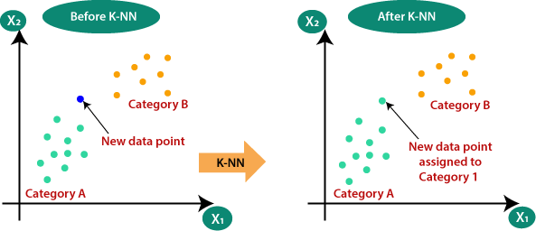

**Code**

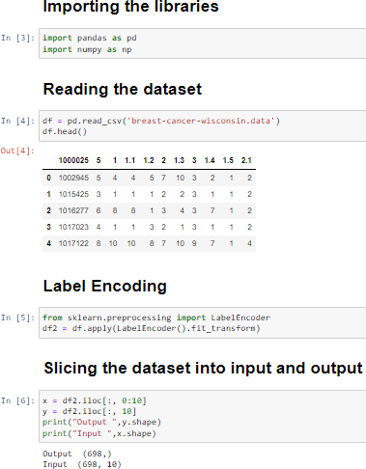

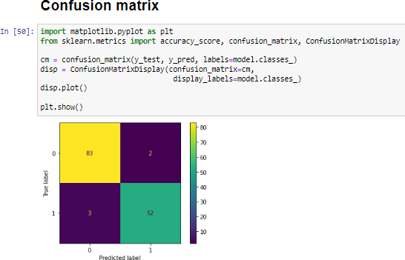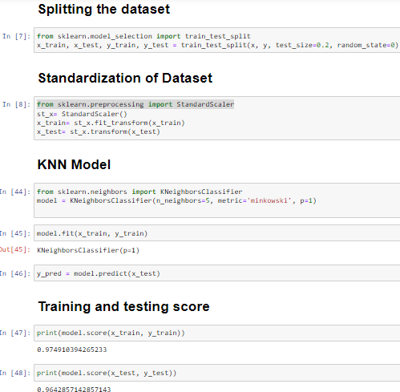

**Conclusion:**

Thus we have successfully completed the implementation of KNN algorithm

**Assignment 11**

**Aim:** Implement CNN for MNIST/CIFAR10 dataset using tensorflow

## Objectives:

1. To learn basics of deep learning
2. To learn and implement CNN

## Theory:

* **Deep Learning:**

⇒ Deep learning is an artificial intelligence function that imitates the workings of the human brain in processing data and creating patterns for use in decision making.

⇒ Deep learning is a subset of machine learning in artificial intelligence(AI) that has networks capable of learning unsupervised from data that is unstructured or unlabelled. Also known as deep neural learning or deep neural network.

⇒ Utilizes a hierarchical level of artificial neural networks to carry out the process of machine learning, they are built like the human brain, with neuron nodes connected together like a web.

## CNN Architecture:

⇒ A CNN architecture is formed by a stack of distinct layers that transform the input volume into an output volume through a differentiable function.

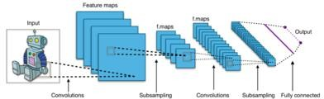

## CNN WORKING

**Step 1. Convolution Operation**

⇒ The first building block in our plan of attack is convolution operation.

⇒ Feature detectors, which basically serve as the neural network's filters.

⇒ Feature maps, learning the parameters of such maps, how patterns are detected, the layers of detection, and how the findings are mapped out.

**ReLU Layer:** Rectified Linear Unit or ReLU

## Step 2. Pooling:

⇒ Pooling layers are used to reduce the dimensions of the feature maps.

⇒ Thus, it reduces the number of parameters to learn and the amount of computation performed in the network.

⇒ The pooling layer summarises the features present in a region of the feature map generated by a convolution layer

## Step 3. Flattening:

⇒ This will be a brief breakdown of the flattening process and how we move from pooled to flattened layers when working with Convolutional Neural Networks.

⇒ Flattening is converting the data into a 1-dimensional array for inputting it to the next layer.

⇒ We flatten the output of the convolutional layers to create a single long feature vector.

## Step 4. Full Connection:

⇒ learning this, you'll get to envision a fuller picture of how Convolutional Neural Networks operate and how the "neurons" that are finally produced learn the classification of images.

⇒ A fully connected layer multiplies the input by a weight matrix and then adds a bias vector.

⇒ The convolutional (and down-sampling) layers are followed by one or more fully connected layers.

⇒ As the name suggests, all neurons in a fully connected layer connect to all the neurons in the previous layer.

**Code & Output:**

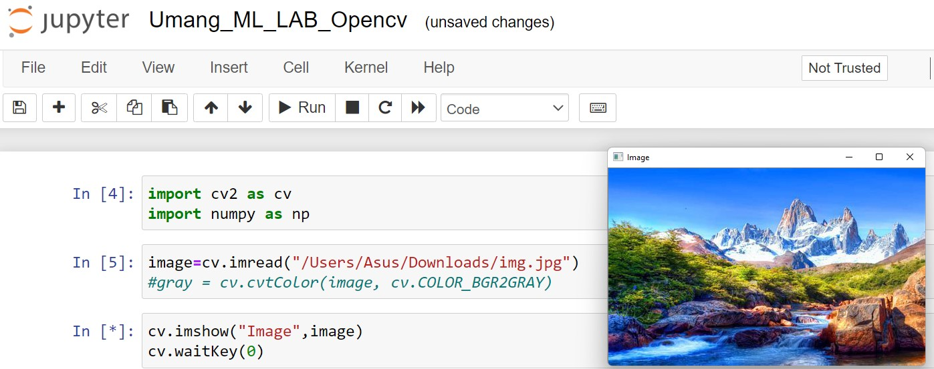

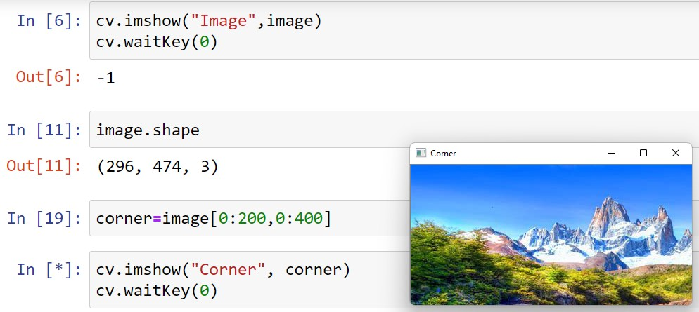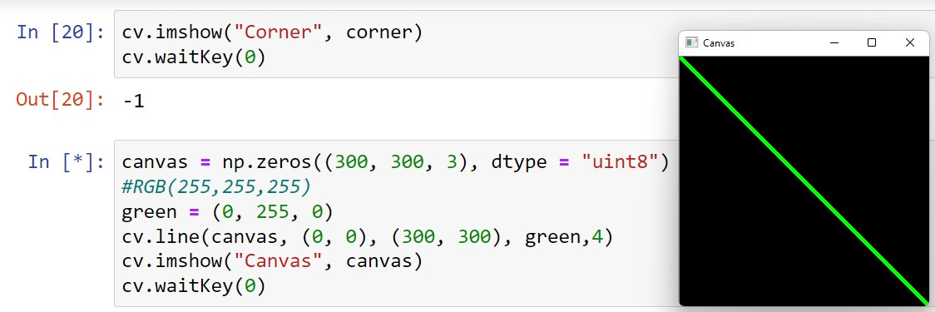

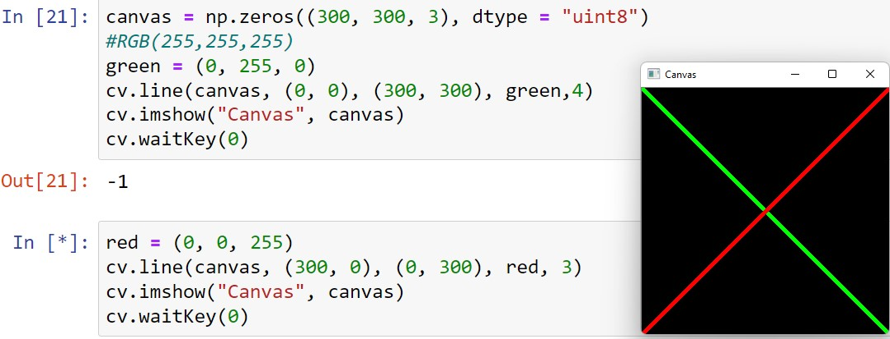

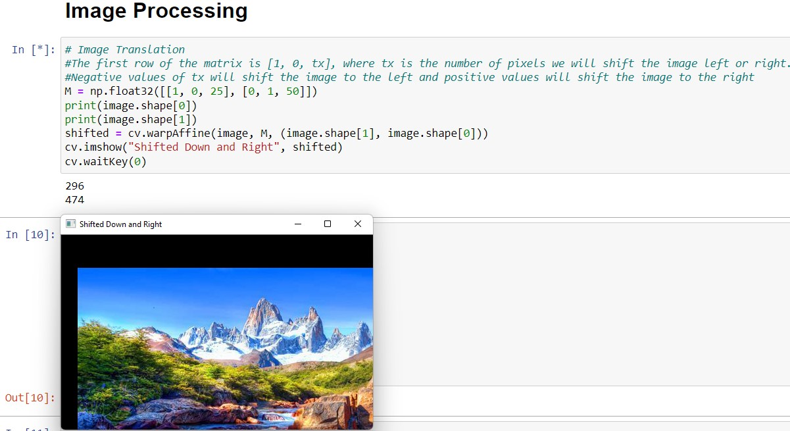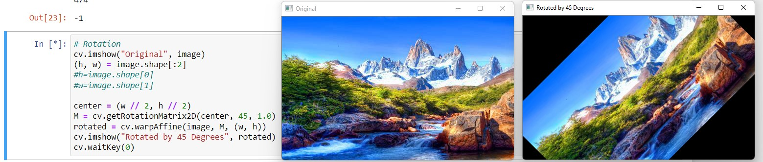

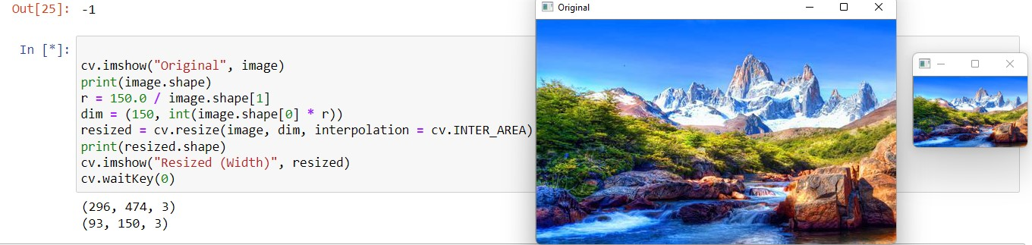

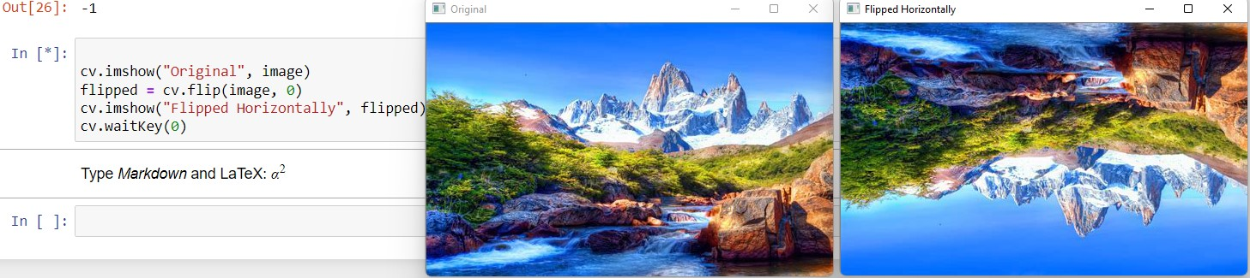

**Conclusion:**

Thus we have successfully completed the implementation of CNN algorithm using tensorflow

**Assignment 12**

**Aim:** Perform basic image processing using opencv

## Objectives:

1. To learn about images processing
2. To perform various operations on images

## Theory:

* **OpenCV**

⇒ OpenCV (Open Source Computer Vision Library) is a library of programming functions mainly aimed at real-time computer vision.

⇒ Originally developed by Intel, it was later supported by Willow Garage then Itseez (which was later acquired by Intel)

⇒ The library is cross-platform and free for use under the open-source BSD license.

⇒ OpenCV supports some models from deep learning frameworks like TensorFlow, Torch, PyTorch (after converting to an ONNX model) and Caffe according to a defined list of supported layers.

⇒ It promotes OpenVisionCapsules, which is a portable format, compatible with all other formats.

## Image processing operations

⇒ **Digital image processing** is the use of a digital computer to process digital images through an algorithm.

⇒ As a subcategory or field of digital signal processing, digital image processing has many advantages over analog image processing.

⇒ It allows a much wider range of algorithms to be applied to the input data and can avoid problems such as the build-up of noise and distortion during processing.

⇒ Since images are defined over two dimensions (perhaps more) digital image processing may be modelled in the form of multidimensional systems.

⇒ The generation and development of digital image processing are mainly affected by three factors:

* 1. The development of computers
  2. The development of mathematics (especially the creation and improvement of discrete mathematics theory)
  3. The demand for a wide range of applications in environment, agriculture, military, industry and medical science has increased.

⇒ digital image processing is a concrete application of, and a practical technology based on:

* + 1. Classification
    2. Feature extraction
    3. Multi-scale signal analysis
    4. Pattern recognition
    5. Projection
    6. Some techniques which are used in digital image processing include:
    7. Anisotropic diffusion
    8. Hidden Markov models, etc

## OpenCV methods:

⇒ Image Acquisition

⇒ Histogram Equalization

⇒ Erosion and Dilation

⇒ Image Denoising

**Code & Output:**

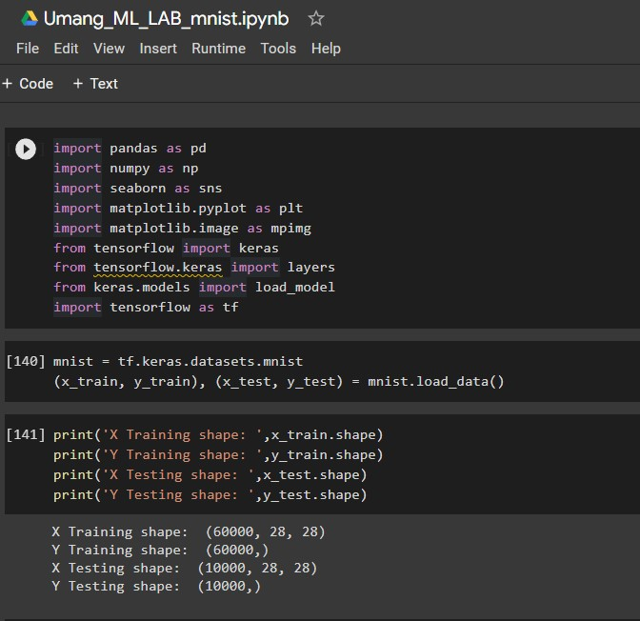

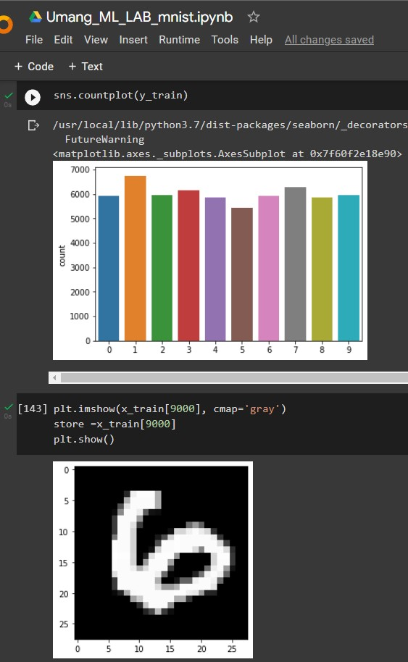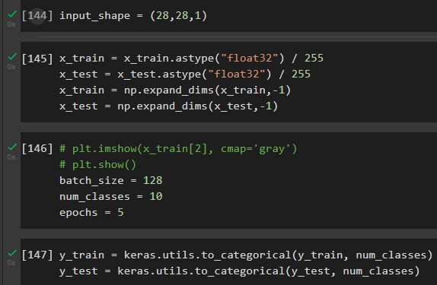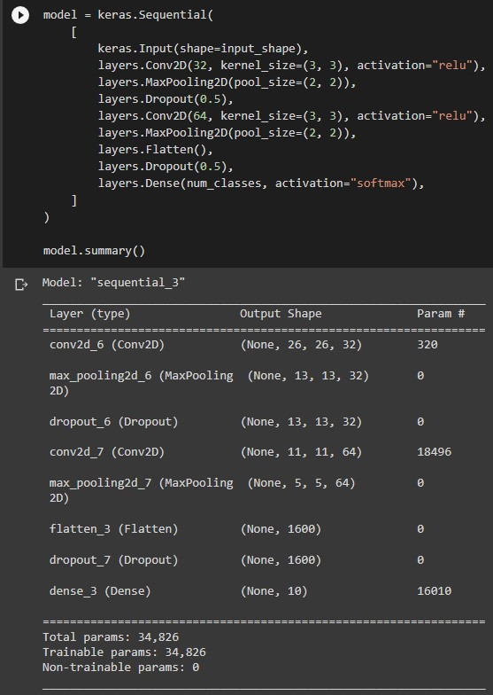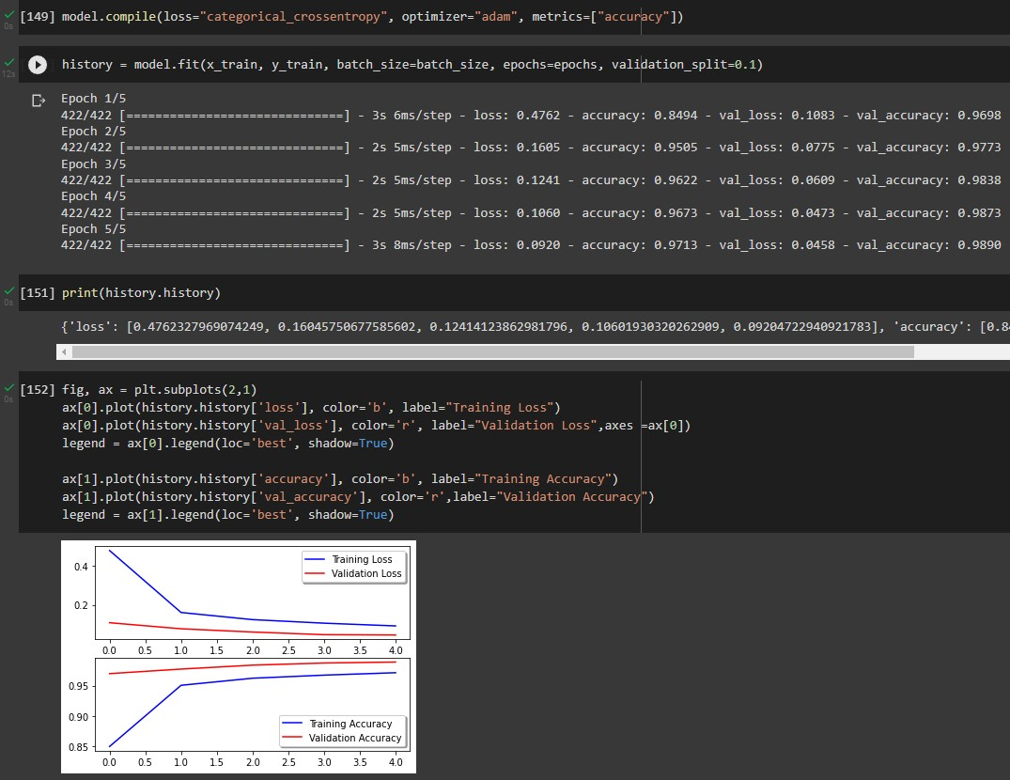

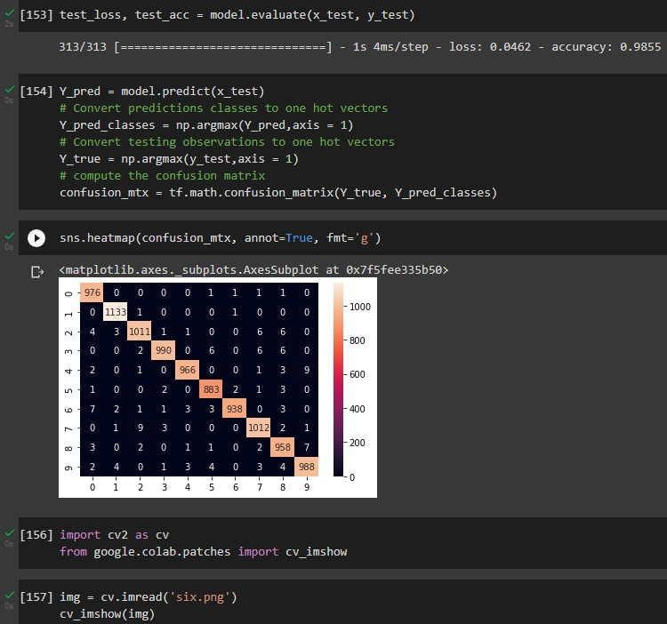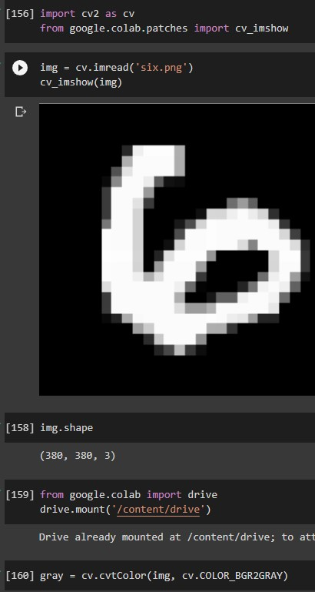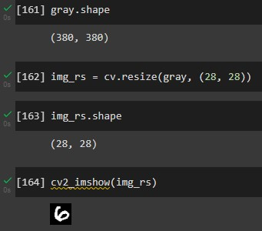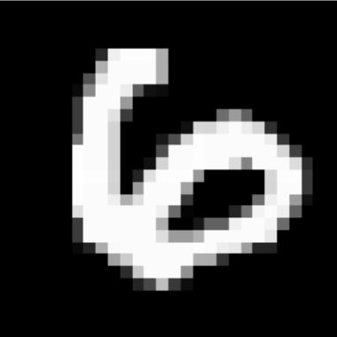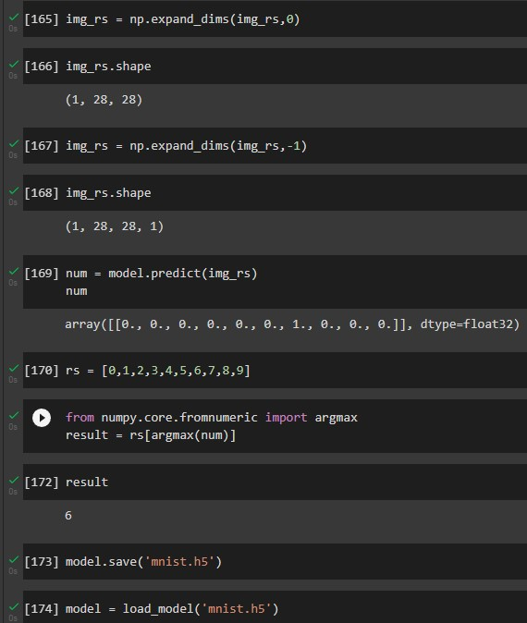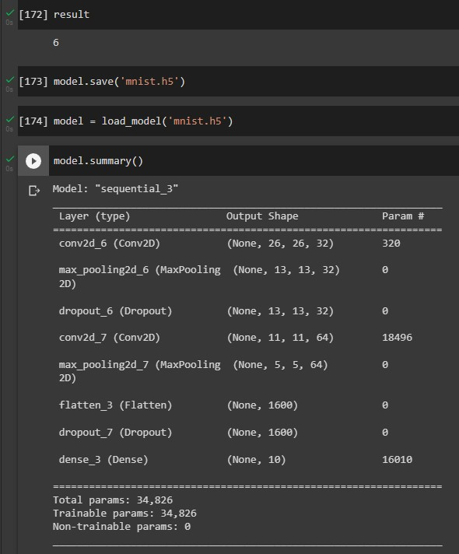

**Conclusion:**

Thus, we have successfully learned the usage of OpenCV and its functions